**MSCD 600 Database Architecture**

**Lab 3**

The purpose of this lab is to build on your knowledge of SQL.

To show that you have successfully executed each step, you can either cut and paste the output on your screen and paste it into this Word document, or you can capture screen shots and paste them into this document. For information on how you will be evaluated, refer to the Labs Rubric at the end of this document below.

Login to the database with your username before starting. To login, refer to the Course Resources\Student_Instructions_Static_Database_Xen_Servers.pdf which is also located in the Course Resources folder for easy access throughout this course.

*/

--------------------------------------------------------

-- First, verify that you’re logged on as your user:

SHOW USER;

SELECT * FROM user_users;

SELECT systimestamp FROM dual;

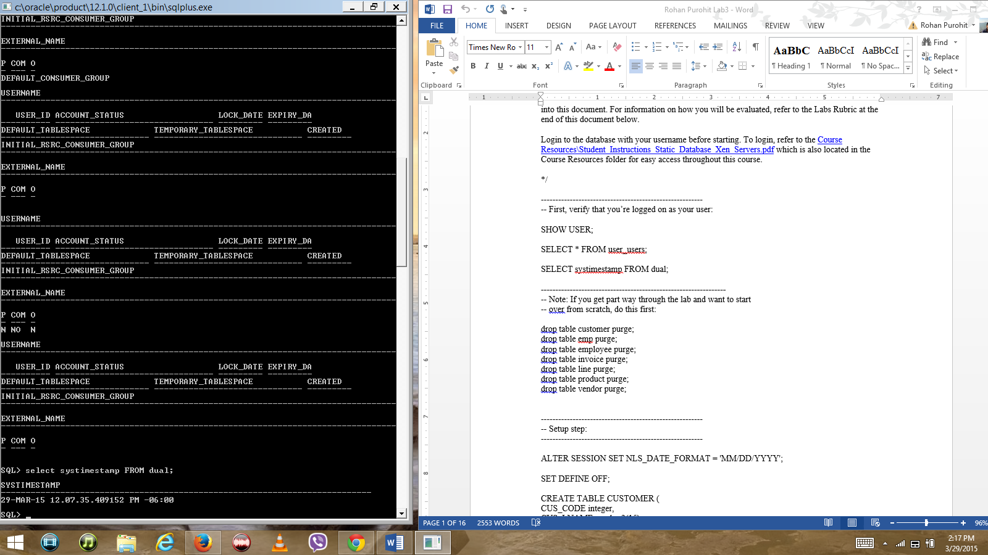

**----------------------------------------------------------------**

-- Note: If you get part way through the lab and want to start

-- over from scratch, do this first:

drop table customer purge;

drop table emp purge;

drop table employee purge;

drop table invoice purge;

drop table line purge;

drop table product purge;

drop table vendor purge;

--------------------------------------------------------

-- Setup step:

--------------------------------------------------------

ALTER SESSION SET NLS_DATE_FORMAT = 'MM/DD/YYYY';

SET DEFINE OFF;

CREATE TABLE CUSTOMER (

CUS_CODE integer,

CUS_LNAME varchar2(15),

CUS_FNAME varchar2(15),

CUS_INITIAL varchar2(1),

CUS_AREACODE varchar2(3),

CUS_PHONE varchar2(8),

CUS_BALANCE number(9,2)

);

I,’

INSERT INTO CUSTOMER VALUES('10011','Dunne','Leona','K','713','894-1238','0');

INSERT INTO CUSTOMER VALUES('10012','Smith','Kathy','W','615','894-2285','345.86');

INSERT INTO CUSTOMER VALUES('10013','Olowski','Paul','F','615','894-2180','536.75');

INSERT INTO CUSTOMER VALUES('10014','Orlando','Myron','','615','222-1672','0');

INSERT INTO CUSTOMER VALUES('10015','O''Brian','Amy','B','713','442-3381','0');

INSERT INTO CUSTOMER VALUES('10016','Brown','James','G','615','297-1228','221.19');

INSERT INTO CUSTOMER VALUES('10017','Williams','George','','615','290-2556','768.93');

INSERT INTO CUSTOMER VALUES('10018','Farriss','Anne','G','713','382-7185','216.55');

INSERT INTO CUSTOMER VALUES('10019','Smith','Olette','K','615','297-3809','0');

CREATE TABLE EMP (

EMP_NUM integer,

EMP_TITLE varchar2(4),

EMP_LNAME varchar2(15),

EMP_FNAME varchar2(15),

EMP_INITIAL varchar2(1),

EMP_DOB date,

EMP_HIRE_DATE date,

EMP_AREACODE varchar2(3),

EMP_PHONE varchar2(8),

EMP_MGR integer

);

INSERT INTO EMP VALUES('100','Mr.','Kolmycz','George','D','6/15/1942','3/15/1985','615','324-5456','');

INSERT INTO EMP VALUES('101','Ms.','Lewis','Rhonda','G','3/19/1965','4/25/1986','615','324-4472','100');

INSERT INTO EMP VALUES('102','Mr.','VanDam','Rhett','','11/14/1958','12/20/1990','901','675-8993','100');

INSERT INTO EMP VALUES('103','Ms.','Jones','Anne','M','10/16/1974','8/28/1994','615','898-3456','100');

INSERT INTO EMP VALUES('104','Mr.','Lange','John','P','11/8/1971','10/20/1994','901','504-4430','105');

INSERT INTO EMP VALUES('105','Mr.','Williams','Robert','D','3/14/1975','11/8/1998','615','890-3220','');

INSERT INTO EMP VALUES('106','Mrs.','Smith','Jeanine','K','2/12/1968','1/5/1989','615','324-7883','105');

INSERT INTO EMP VALUES('107','Mr.','Diante','Jorge','D','8/21/1974','7/2/1994','615','890-4567','105');

INSERT INTO EMP VALUES('108','Mr.','Wiesenbach','Paul','R','2/14/1966','11/18/1992','615','897-4358','');

INSERT INTO EMP VALUES('109','Mr.','Smith','George','K','6/18/1961','4/14/1989','901','504-3339','108');

INSERT INTO EMP VALUES('110','Mrs.','Genkazi','Leighla','W','5/19/1970','12/1/1990','901','569-0093','108');

INSERT INTO EMP VALUES('111','Mr.','Washington','Rupert','E','1/3/1966','6/21/1993','615','890-4925','105');

INSERT INTO EMP VALUES('112','Mr.','Johnson','Edward','E','5/14/1961','12/1/1983','615','898-4387','100');

INSERT INTO EMP VALUES('113','Ms.','Smythe','Melanie','P','9/15/1970','5/11/1999','615','324-9006','105');

INSERT INTO EMP VALUES('114','Ms.','Brandon','Marie','G','11/2/1956','11/15/1979','901','882-0845','108');

INSERT INTO EMP VALUES('115','Mrs.','Saranda','Hermine','R','7/25/1972','4/23/1993','615','324-5505','105');

INSERT INTO EMP VALUES('116','Mr.','Smith','George','A','11/8/1965','12/10/1988','615','890-2984','108');

CREATE TABLE EMPLOYEE (

EMP_NUM integer,

EMP_TITLE varchar2(4),

EMP_LNAME varchar2(15),

EMP_FNAME varchar2(15),

EMP_INITIAL varchar2(1),

EMP_DOB date,

EMP_HIRE_DATE date,

EMP_YEARS integer,

EMP_AREACODE varchar2(3),

EMP_PHONE varchar2(8)

);

INSERT INTO EMPLOYEE VALUES('100','Mr.','Kolmycz','George','D','6/15/1942','3/15/1985','18','615','324-5456');

INSERT INTO EMPLOYEE VALUES('101','Ms.','Lewis','Rhonda','G','3/19/1965','4/25/1986','16','615','324-4472');

INSERT INTO EMPLOYEE VALUES('102','Mr.','VanDam','Rhett','','11/14/1958','12/20/1990','12','901','675-8993');

INSERT INTO EMPLOYEE VALUES('103','Ms.','Jones','Anne','M','10/16/1974','8/28/1994','8','615','898-3456');

INSERT INTO EMPLOYEE VALUES('104','Mr.','Lange','John','P','11/8/1971','10/20/1994','8','901','504-4430');

INSERT INTO EMPLOYEE VALUES('105','Mr.','Williams','Robert','D','3/14/1975','11/8/1998','4','615','890-3220');

INSERT INTO EMPLOYEE VALUES('106','Mrs.','Smith','Jeanine','K','2/12/1968','1/5/1989','14','615','324-7883');

INSERT INTO EMPLOYEE VALUES('107','Mr.','Diante','Jorge','D','8/21/1974','7/2/1994','8','615','890-4567');

INSERT INTO EMPLOYEE VALUES('108','Mr.','Wiesenbach','Paul','R','2/14/1966','11/18/1992','10','615','897-4358');

INSERT INTO EMPLOYEE VALUES('109','Mr.','Smith','George','K','6/18/1961','4/14/1989','13','901','504-3339');

INSERT INTO EMPLOYEE VALUES('110','Mrs.','Genkazi','Leighla','W','5/19/1970','12/1/1990','12','901','569-0093');

INSERT INTO EMPLOYEE VALUES('111','Mr.','Washington','Rupert','E','1/3/1966','6/21/1993','9','615','890-4925');

INSERT INTO EMPLOYEE VALUES('112','Mr.','Johnson','Edward','E','5/14/1961','12/1/1983','19','615','898-4387');

INSERT INTO EMPLOYEE VALUES('113','Ms.','Smythe','Melanie','P','9/15/1970','5/11/1999','3','615','324-9006');

INSERT INTO EMPLOYEE VALUES('114','Ms.','Brandon','Marie','G','11/2/1956','11/15/1979','23','901','882-0845');

INSERT INTO EMPLOYEE VALUES('115','Mrs.','Saranda','Hermine','R','7/25/1972','4/23/1993','9','615','324-5505');

INSERT INTO EMPLOYEE VALUES('116','Mr.','Smith','George','A','11/8/1965','12/10/1988','14','615','890-2984');

CREATE TABLE INVOICE (

INV_NUMBER integer,

CUS_CODE integer,

INV_DATE date

);

INSERT INTO INVOICE VALUES('1001','10014','1/16/2010');

INSERT INTO INVOICE VALUES('1002','10011','1/16/2010');

INSERT INTO INVOICE VALUES('1003','10012','1/16/2010');

INSERT INTO INVOICE VALUES('1004','10011','1/17/2010');

INSERT INTO INVOICE VALUES('1005','10018','1/17/2010');

INSERT INTO INVOICE VALUES('1006','10014','1/17/2010');

INSERT INTO INVOICE VALUES('1007','10015','1/17/2010');

INSERT INTO INVOICE VALUES('1008','10011','1/17/2010');

CREATE TABLE LINE (

INV_NUMBER integer,

LINE_NUMBER integer,

P_CODE varchar2(10),

LINE_UNITS number(9,2),

LINE_PRICE number(9,2)

);

INSERT INTO LINE VALUES('1001','1','13-Q2/P2','1','14.99');

INSERT INTO LINE VALUES('1001','2','23109-HB','1','9.95');

INSERT INTO LINE VALUES('1002','1','54778-2T','2','4.99');

INSERT INTO LINE VALUES('1003','1','2238/QPD','1','38.95');

INSERT INTO LINE VALUES('1003','2','1546-QQ2','1','39.95');

INSERT INTO LINE VALUES('1003','3','13-Q2/P2','5','14.99');

INSERT INTO LINE VALUES('1004','1','54778-2T','3','4.99');

INSERT INTO LINE VALUES('1004','2','23109-HB','2','9.95');

INSERT INTO LINE VALUES('1005','1','PVC23DRT','12','5.87');

INSERT INTO LINE VALUES('1006','1','SM-18277','3','6.99');

INSERT INTO LINE VALUES('1006','2','2232/QTY','1','109.92');

INSERT INTO LINE VALUES('1006','3','23109-HB','1','9.95');

INSERT INTO LINE VALUES('1006','4','89-WRE-Q','1','256.99');

INSERT INTO LINE VALUES('1007','1','13-Q2/P2','2','14.99');

INSERT INTO LINE VALUES('1007','2','54778-2T','1','4.99');

INSERT INTO LINE VALUES('1008','1','PVC23DRT','5','5.87');

INSERT INTO LINE VALUES('1008','2','WR3/TT3','3','119.95');

INSERT INTO LINE VALUES('1008','3','23109-HB','1','9.95');

CREATE TABLE PRODUCT (

P_CODE varchar2(10),

P_DESCRIPT varchar2(35),

P_INDATE date,

P_QOH integer,

P_MIN integer,

P_PRICE number(8,2),

P_DISCOUNT number(5,2),

V_CODE integer

);

INSERT INTO PRODUCT VALUES('11QER/31','Power painter, 15 psi., 3-nozzle','11/3/2009','8','5','109.99','0','25595');

INSERT INTO PRODUCT VALUES('13-Q2/P2','7.25-in. pwr. saw blade','12/13/2009','32','15', '14.99','0.05','21344');

INSERT INTO PRODUCT VALUES('14-Q1/L3','9.00-in. pwr. saw blade','11/13/2009','18','12','17.49','0','21344');

INSERT INTO PRODUCT VALUES('1546-QQ2','Hrd. cloth, 1/4-in., 2x50','1/15/2010','15','8','39.95','0','23119');

INSERT INTO PRODUCT VALUES('1558-QW1','Hrd. cloth, 1/2-in., 3x50','1/15/2010','23','5','43.99','0','23119');

INSERT INTO PRODUCT VALUES('2232/QTY','B\&D jigsaw, 12-in. blade','12/30/2009','8','5','109.92','0.05','24288');

INSERT INTO PRODUCT VALUES('2232/QWE','B\&D jigsaw, 8-in. blade','12/24/2009','6','5','99.87','0.05','24288');

INSERT INTO PRODUCT VALUES('2238/QPD','B\&D cordless drill, 1/2-in.','1/20/2010','12','5','38.95','0.05','25595');

INSERT INTO PRODUCT VALUES('23109-HB','Claw hammer','1/20/2010','23','10','9.95','0.1','21225');

INSERT INTO PRODUCT VALUES('23114-AA','Sledge hammer, 12 lb.','1/2/2010','8','5','14.40','0.05','');

INSERT INTO PRODUCT VALUES('54778-2T','Rat-tail file, 1/8-in. fine','12/15/2009','43','20','4.99','0','21344');

INSERT INTO PRODUCT VALUES('89-WRE-Q','Hicut chain saw, 16 in.','2/7/2010','11','5','256.99','0.05','24288');

INSERT INTO PRODUCT VALUES('PVC23DRT','PVC pipe, 3.5-in., 8-ft','2/20/2010','188','75','5.87','0','');

INSERT INTO PRODUCT VALUES('SM-18277','1.25-in. metal screw, 25','3/1/2010','172','75','6.99','0','21225');

INSERT INTO PRODUCT VALUES('SW-23116','2.5-in. wd. screw, 50','2/24/2010','237','100','8.45','0','21231');

INSERT INTO PRODUCT VALUES('WR3/TT3','Steel matting, 4''x8''x1/6", .5" mesh','1/17/2010','18','5','119.95','0.1','25595');

CREATE TABLE VENDOR (

V_CODE integer,

V_NAME varchar2(15),

V_CONTACT varchar2(50),

V_AREACODE varchar2(3),

V_PHONE varchar2(8),

V_STATE varchar2(2),

V_ORDER varchar2(1)

);

INSERT INTO VENDOR VALUES('21225','Bryson, Inc.','Smithson','615','223-3234','TN','Y');

INSERT INTO VENDOR VALUES('21226','SuperLoo, Inc.','Flushing','904','215-8995','FL','N');

INSERT INTO VENDOR VALUES('21231','D&E Supply','Singh','615','228-3245','TN','Y');

INSERT INTO VENDOR VALUES('21344','Gomez Bros.','Ortega','615','889-2546','KY','N');

INSERT INTO VENDOR VALUES('22567','Dome Supply','Smith','901','678-1419','GA','N');

INSERT INTO VENDOR VALUES('23119','Randsets Ltd.','Anderson','901','678-3998','GA','Y');

INSERT INTO VENDOR VALUES('24004','Brackman Bros.','Browning','615','228-1410','TN','N');

INSERT INTO VENDOR VALUES('24288','ORDVA, Inc.','Hakford','615','898-1234','TN','Y');

INSERT INTO VENDOR VALUES('25443','B&K, Inc.','Smith','904','227-0093','FL','N');

INSERT INTO VENDOR VALUES('25501','Damal Supplies','Smythe','615','890-3529','TN','N');

INSERT INTO VENDOR VALUES('25595','Rubicon Systems','Orton','904','456-0092','FL','Y');

SET DEFINE ON;

--

-- Smoke test (what does smoke test mean?)

-- You should see counts of rows for all tables.

select count(*) from customer;

select count(*) from emp;

select count(*) from employee;

select count(*) from invoice;

select count(*) from line;

select count(*) from product;

select count(*) from vendor;

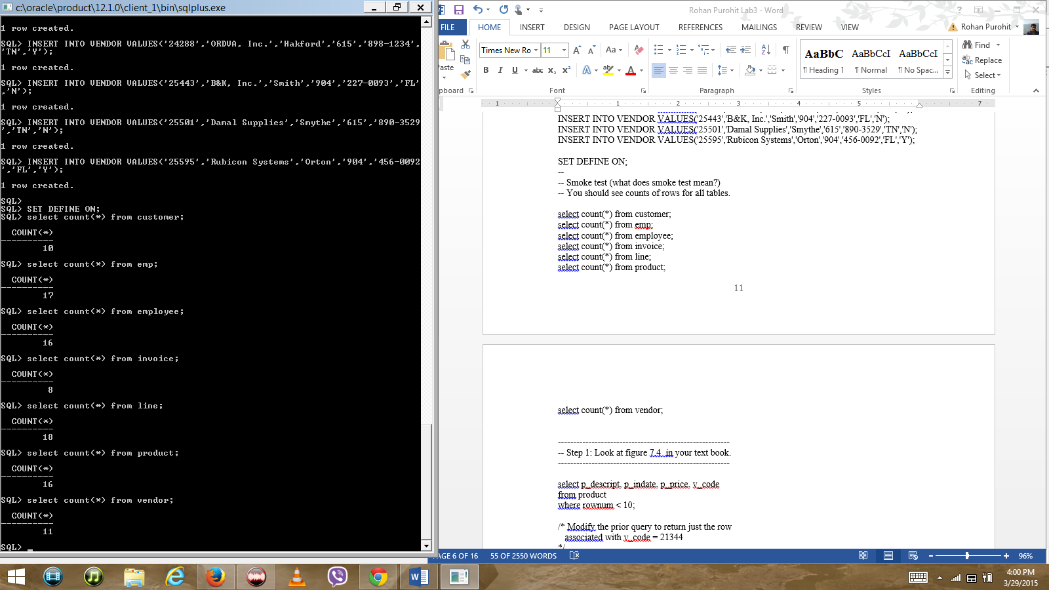

--------------------------------------------------------

-- Step 1: Look at figure 7.4 in your text book.

--------------------------------------------------------

select p_descript, p_indate, p_price, v_code

from product

where rownum < 10;

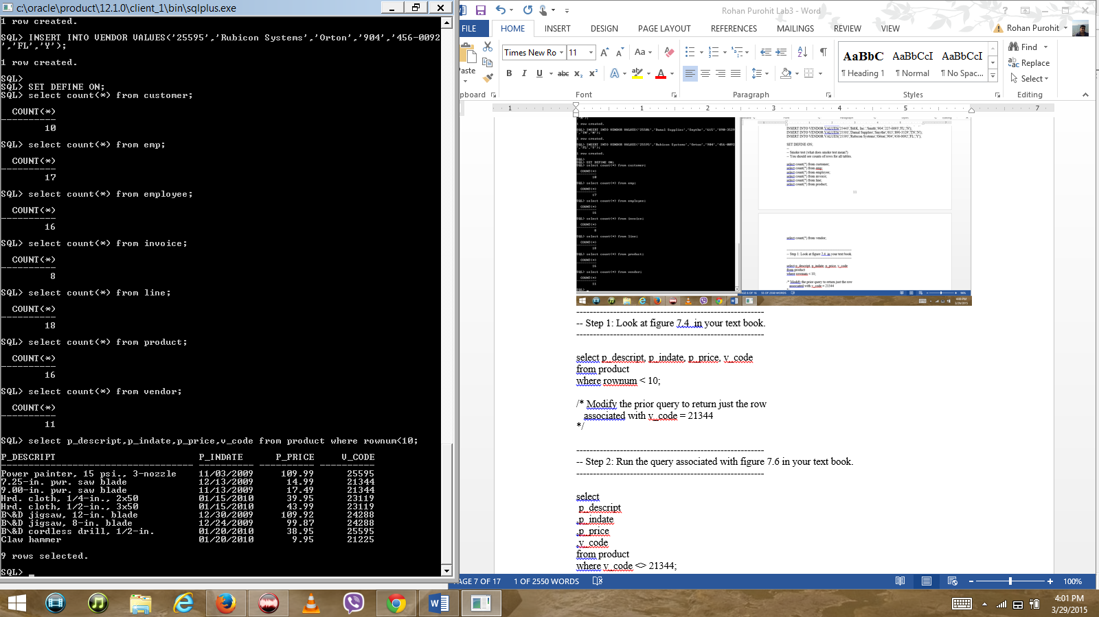

/* Modify the prior query to return just the row

associated with v_code = 21344

*/

--------------------------------------------------------

-- Step 2: Run the query associated with figure 7.6 in your text book.

--------------------------------------------------------

select

p_descript

,p_indate

,p_price

,v_code

from product

where v_code <> 21344;

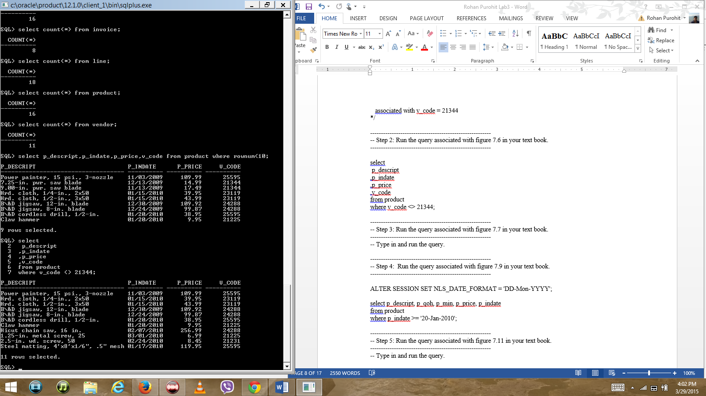

--------------------------------------------------------

-- Step 3: Run the query associated with figure 7.7 in your text book.

--------------------------------------------------------

-- Type in and run the query.

SELECT P_CODE, P_DESCRIPT, P_QOH,P_MIN,P_PRICE FROM PRODUCT WHERE P_CODE < ‘1558-QW1’;

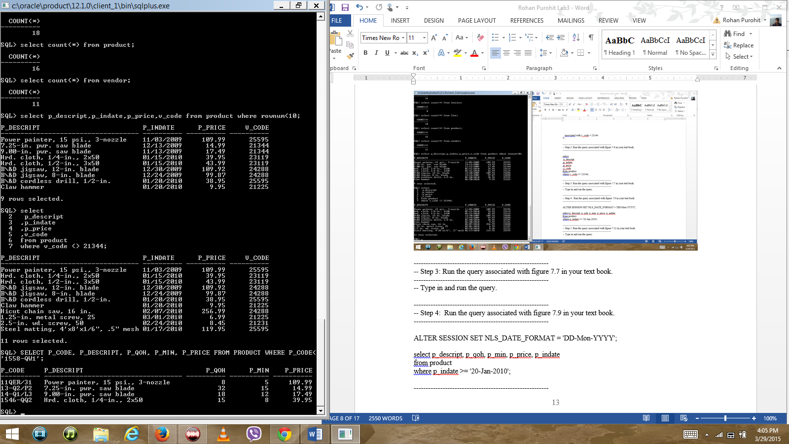

--------------------------------------------------------

-- Step 4: Run the query associated with figure 7.9 in your text book.

--------------------------------------------------------

SELECT P_DESCRIPT,P_QOH,P_PRICE,P_QOH* P_PRICE FROM PRODUCT

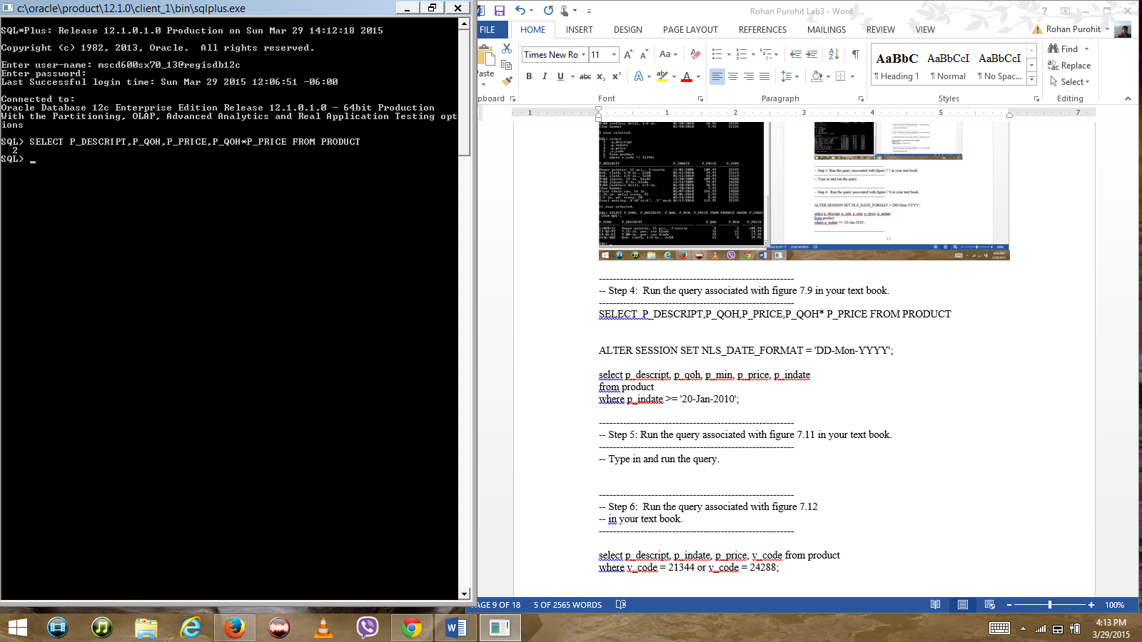

ALTER SESSION SET NLS_DATE_FORMAT = 'DD-Mon-YYYY';

select p_descript, p_qoh, p_min, p_price, p_indate

from product

where p_indate >= '20-Jan-2010';

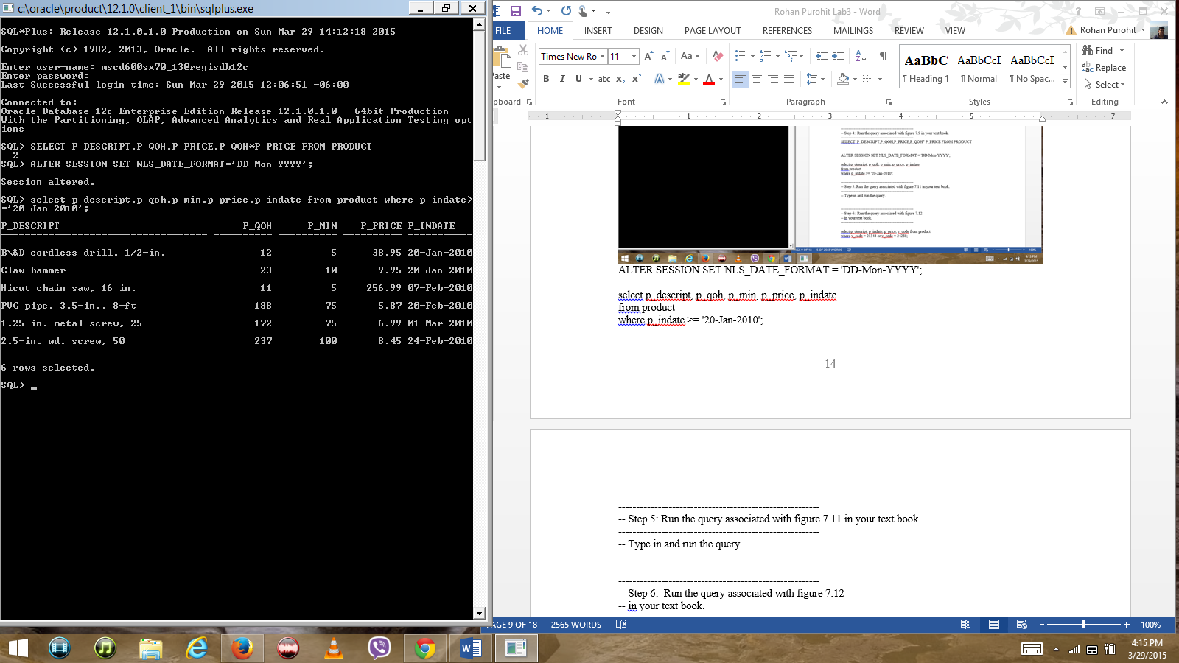

--------------------------------------------------------

-- Step 5: Run the query associated with figure 7.11 in your text book.

--------------------------------------------------------

-- Type in and run the query.

SELECT P_CODE, P_INDATE,SYSDATE-90 AS CUTDATE FROM PRODUCT WHERE P_INDATE <= SYSDATE-90;

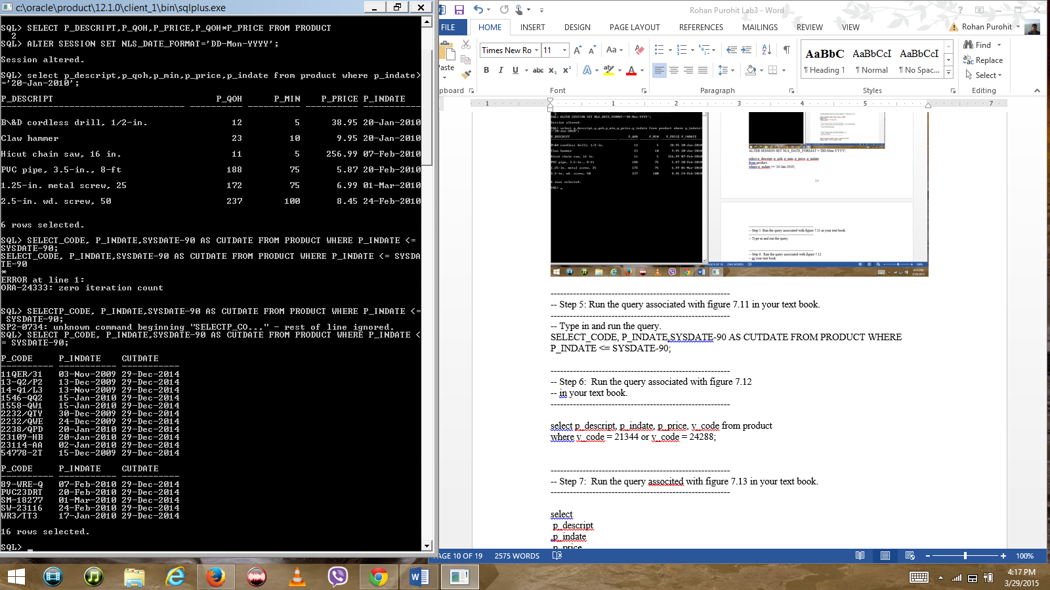

--------------------------------------------------------

-- Step 6: Run the query associated with figure 7.12

-- in your text book.

SELECT P_DESCRIPT,P_INDATE,P_PRICE,V_CODE FROM PRODUCT WHERE P_PRICE <50 AND P_INDATE > ’15- Jan-2014’;

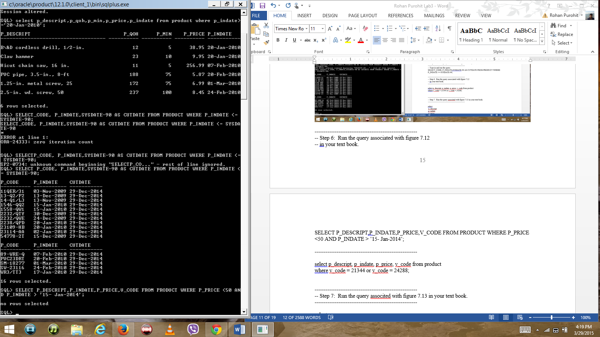

--------------------------------------------------------

select p_descript, p_indate, p_price, v_code from product

where v_code = 21344 or v_code = 24288;

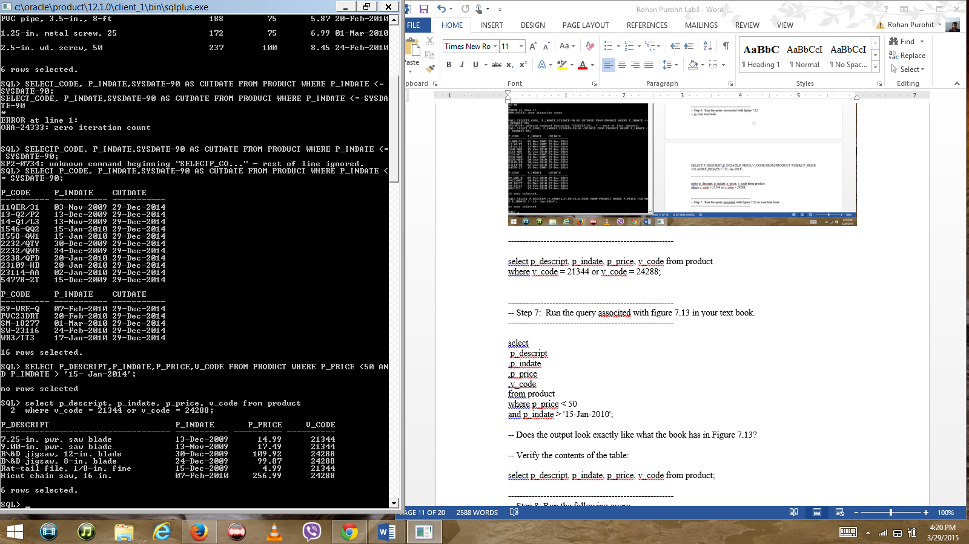

--------------------------------------------------------

-- Step 7: Run the query associted with figure 7.13 in your text book.

--------------------------------------------------------

select

p_descript

,p_indate

,p_price

,v_code

from product

where p_price < 50

and p_indate > '15-Jan-2010';

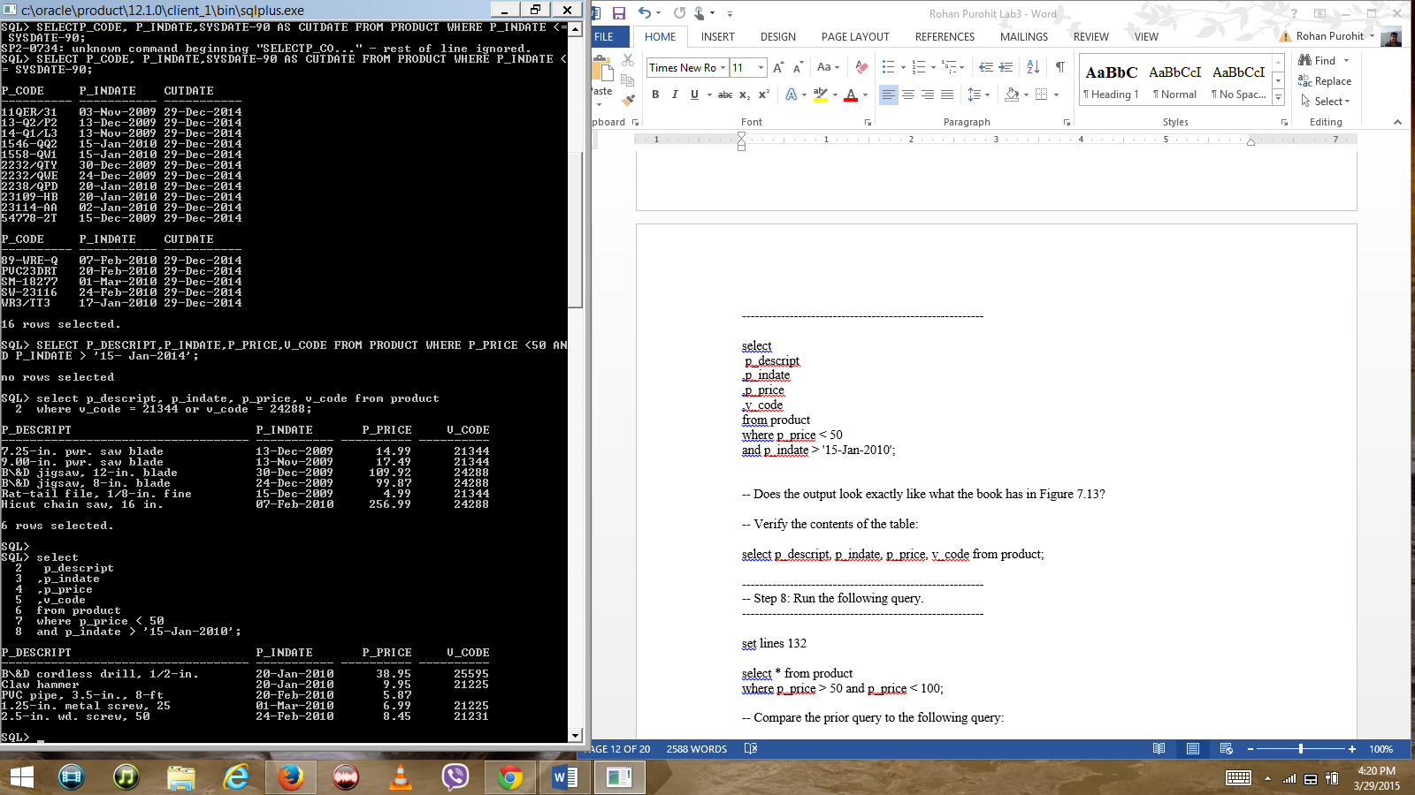

-- Does the output look exactly like what the book has in Figure 7.13?

Yes the output matches the book version.

-- Verify the contents of the table:

select p_descript, p_indate, p_price, v_code from product;

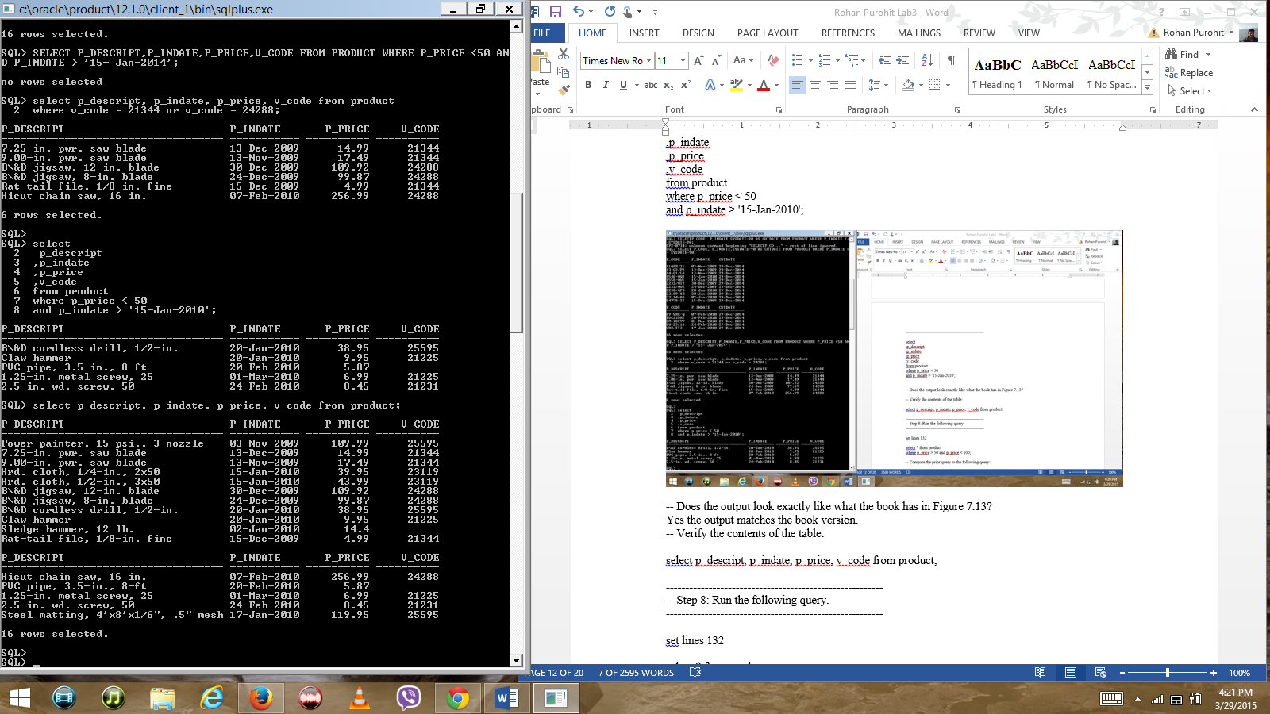

--------------------------------------------------------

-- Step 8: Run the following query.

--------------------------------------------------------

set lines 132

select * from product

where p_price > 50 and p_price < 100;

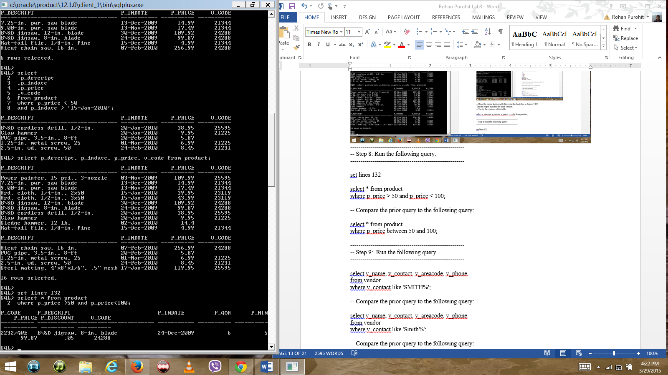

-- Compare the prior query to the following query:

Both queries give the same result set.

select * from product

where p_price between 50 and 100;

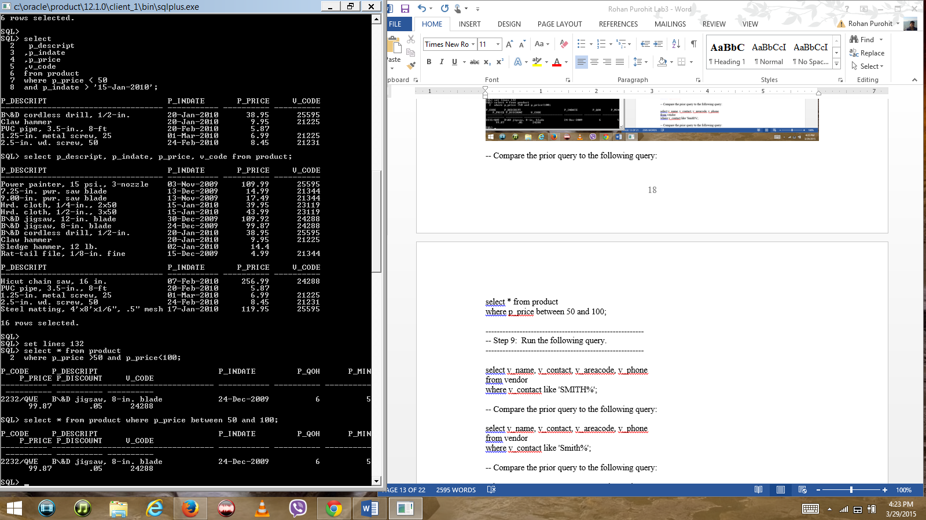

--------------------------------------------------------

-- Step 9: Run the following query.

--------------------------------------------------------

select v_name, v_contact, v_areacode, v_phone

from vendor

where v_contact like 'SMITH%';

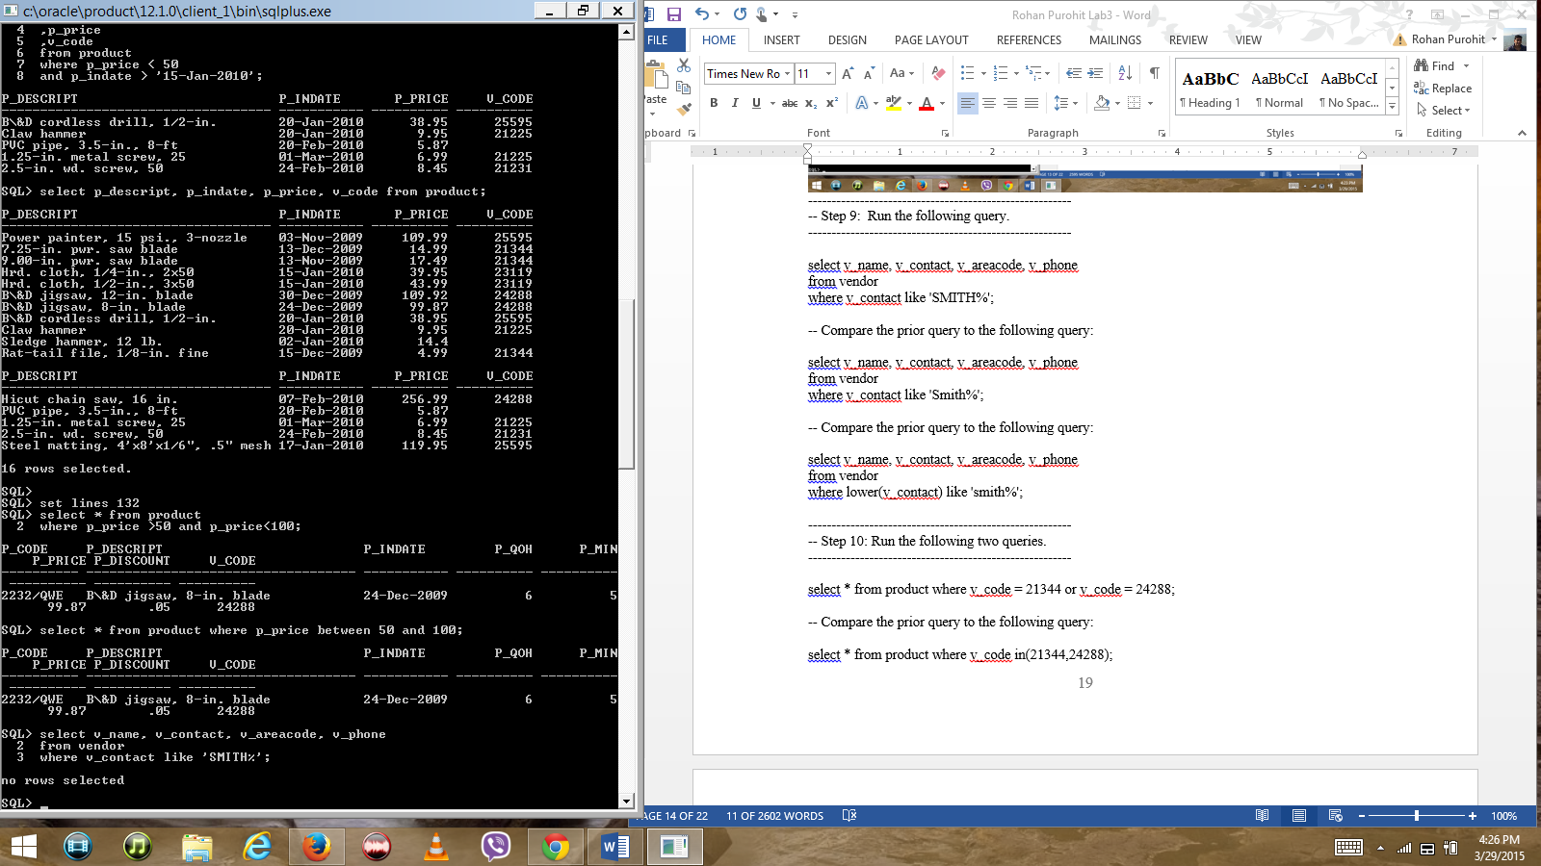

-- Compare the prior query to the following query: both queries return no rows.

select v_name, v_contact, v_areacode, v_phone

from vendor

where v_contact like 'Smith%';

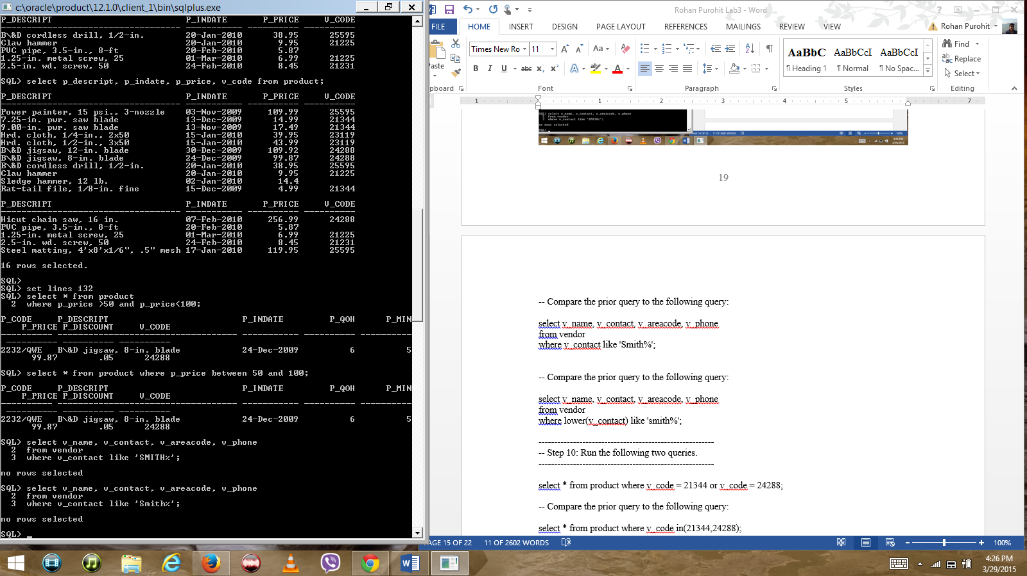

-- Compare the prior query to the following query: no rows selected by both queries.

select v_name, v_contact, v_areacode, v_phone

from vendor

where lower(v_contact) like 'smith%';

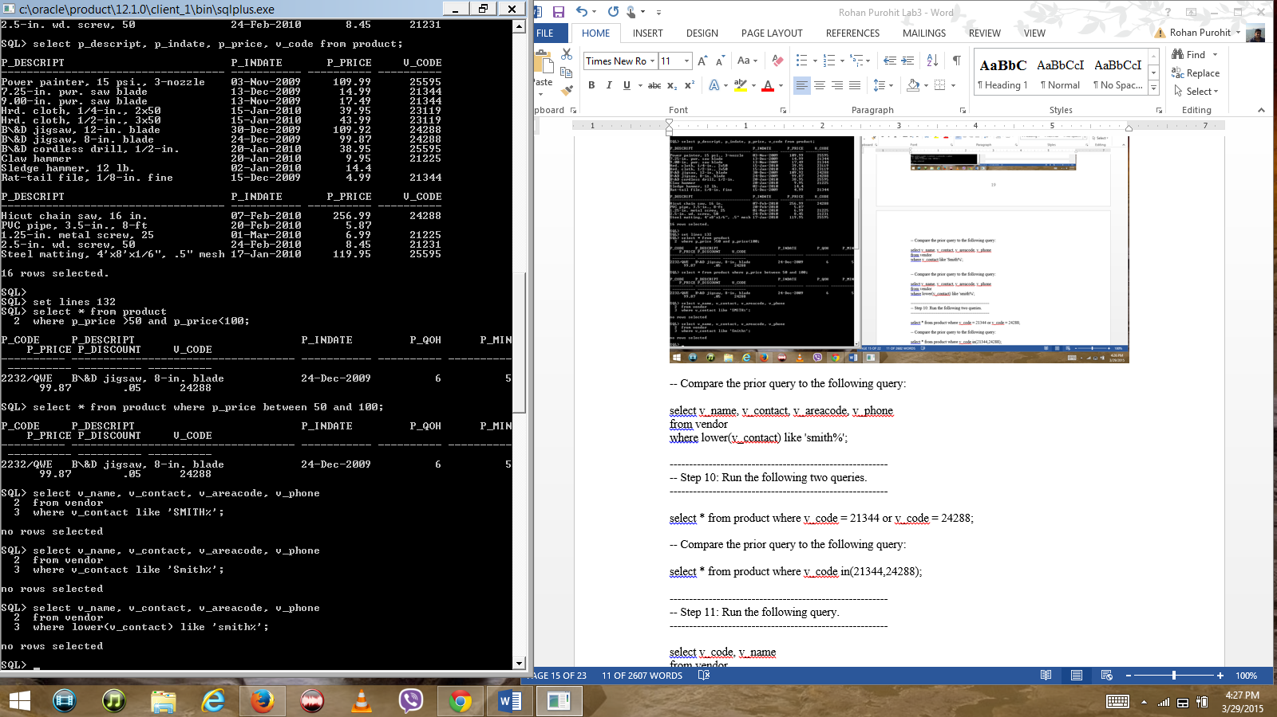

--------------------------------------------------------

-- Step 10: Run the following two queries.

--------------------------------------------------------

select * from product where v_code = 21344 or v_code = 24288;

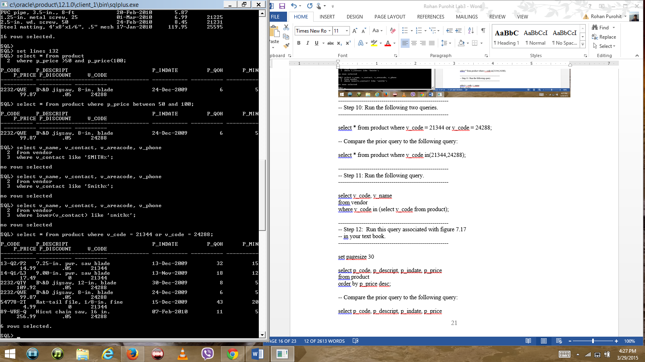

-- Compare the prior query to the following query: both queries give the same result set.

select * from product where v_code in(21344,24288);

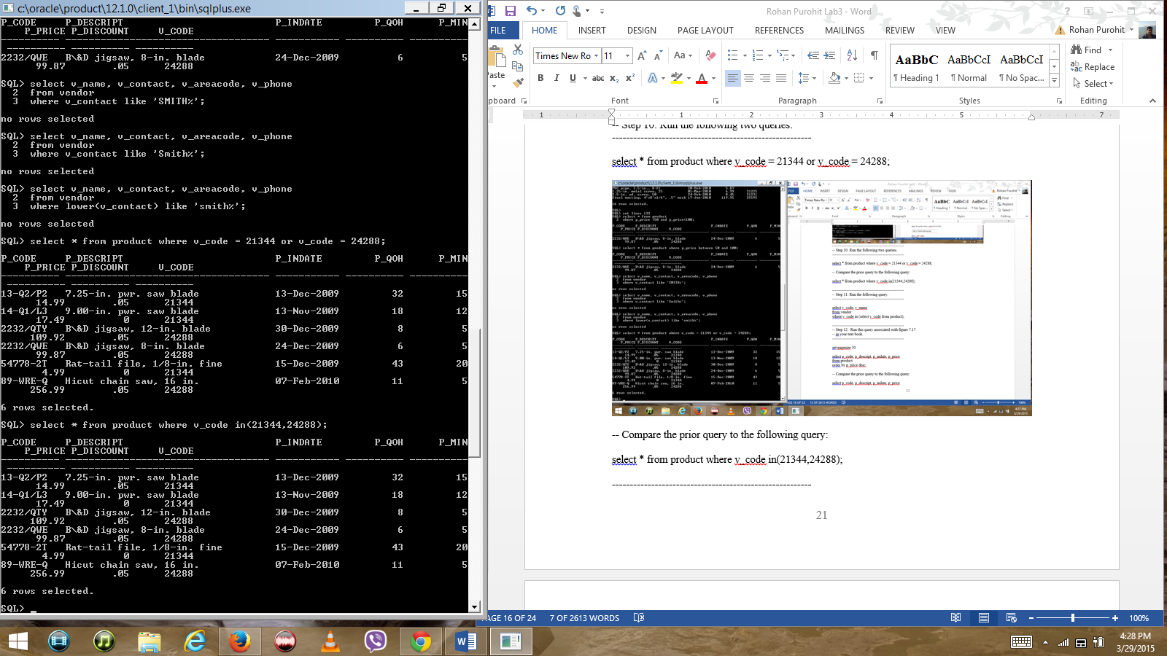

--------------------------------------------------------

-- Step 11: Run the following query.

--------------------------------------------------------

select v_code, v_name

from vendor

where v_code in (select v_code from product);

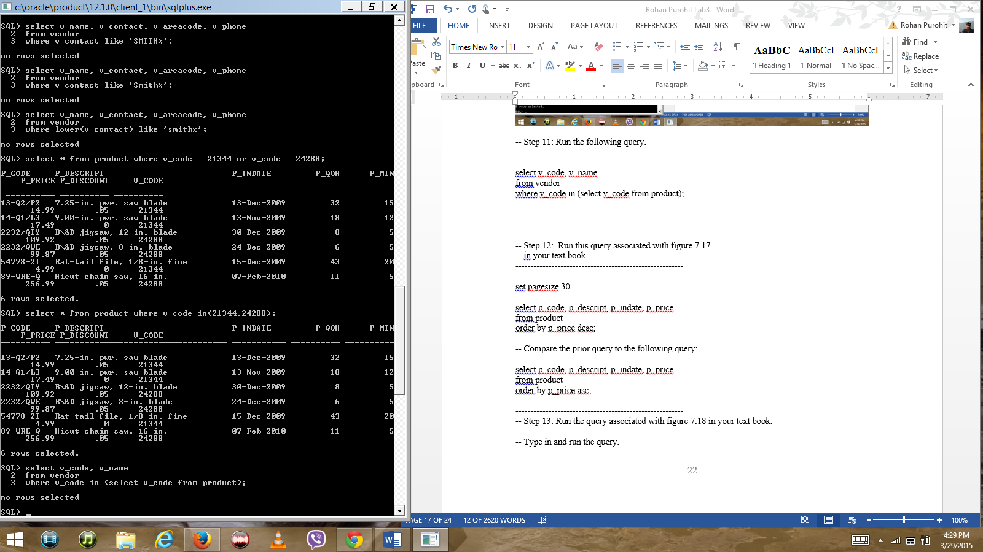

--------------------------------------------------------

-- Step 12: Run this query associated with figure 7.17

-- in your text book.

--------------------------------------------------------

set pagesize 30

select p_code, p_descript, p_indate, p_price

from product

order by p_price desc;

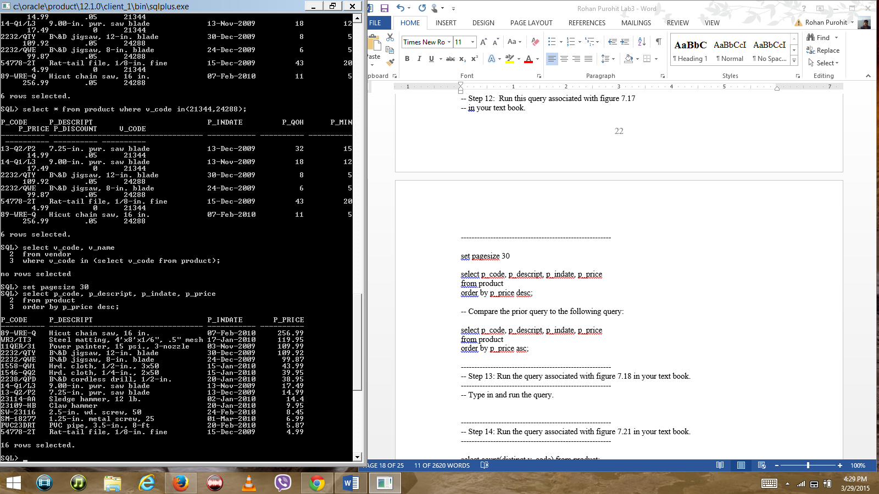

-- Compare the prior query to the following query: both queries give the same result set of 16 rows.

select p_code, p_descript, p_indate, p_price

from product

order by p_price asc;

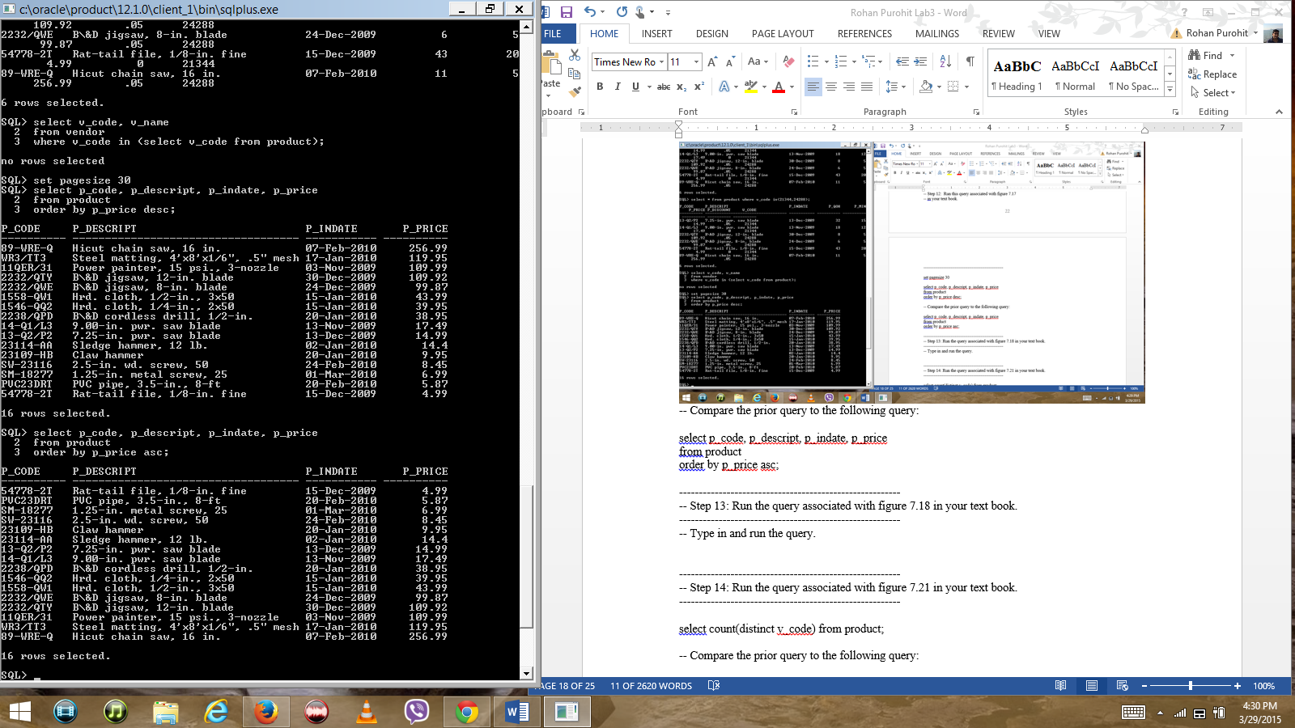

--------------------------------------------------------

-- Step 13: Run the query associated with figure 7.18 in your text book.

--------------------------------------------------------

-- Type in and run the query.

SELECT EMP_LNAME, EMP_FNAME,EMP_INITIAL, EMP_AREACODE,EMP_PHONE FROM EMPLOYEE ORDER BY EMP_LNAME,EMP_FNAME,EMP_INITIAL;

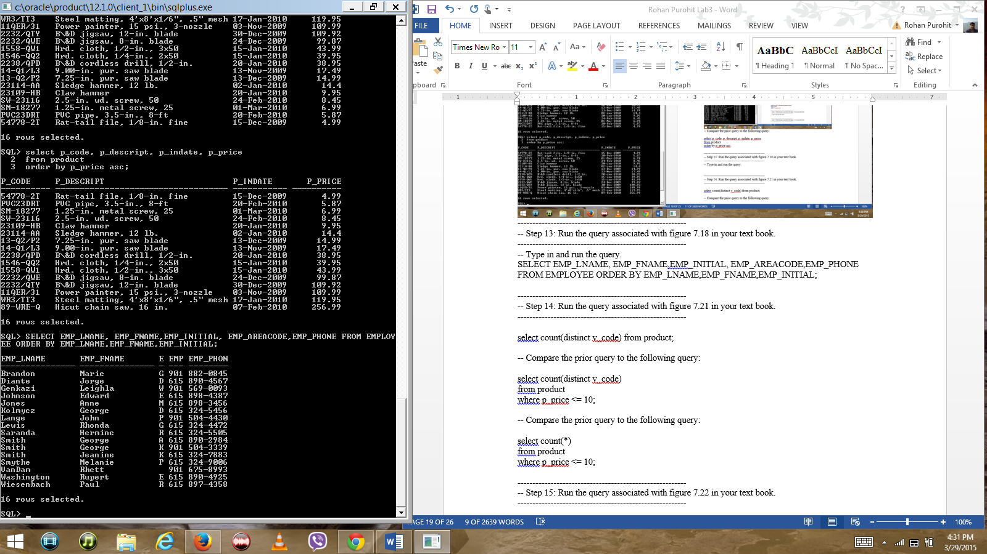

--------------------------------------------------------

-- Step 14: Run the query associated with figure 7.21 in your text book.

--------------------------------------------------------

select count(distinct v_code) from product;

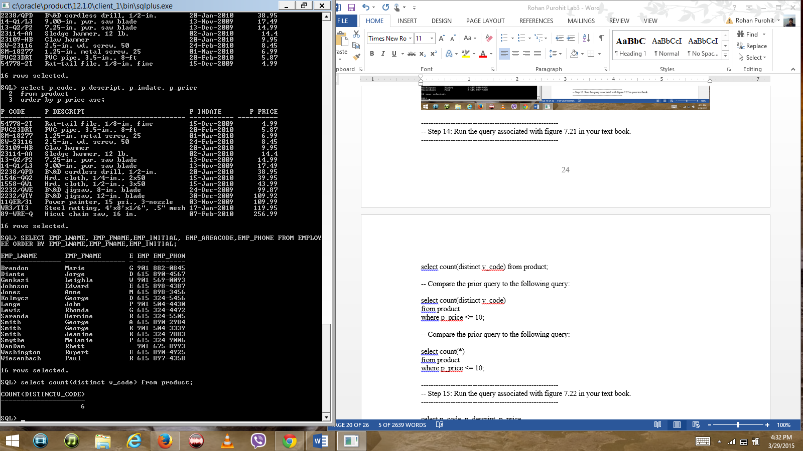

-- Compare the prior query to the following query: the query results 3 instead of 6 as the count.

select count(distinct v_code)

from product

where p_price <= 10;

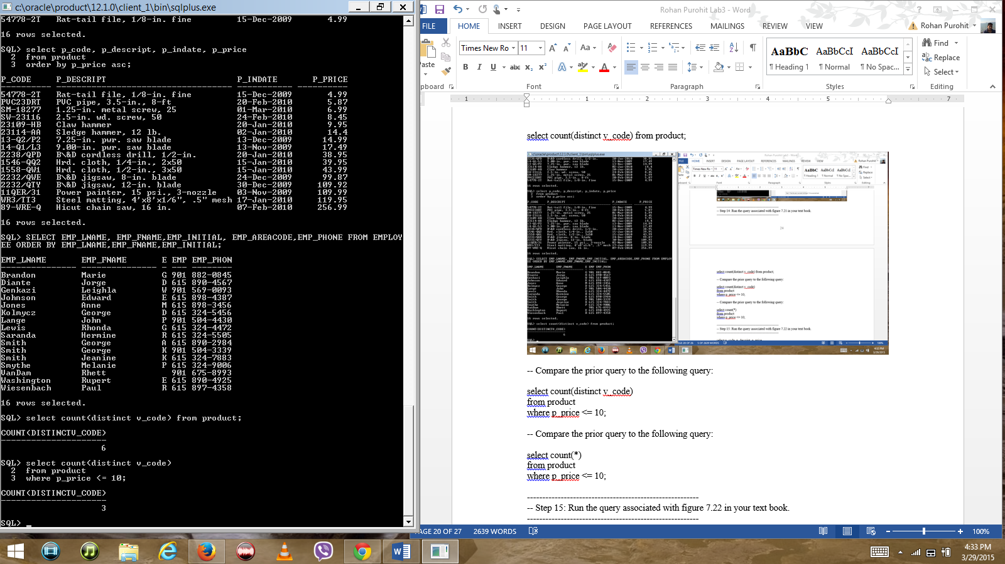

-- Compare the prior query to the following query: We get 5 as the count in this query.

select count(*)

from product

where p_price <= 10;

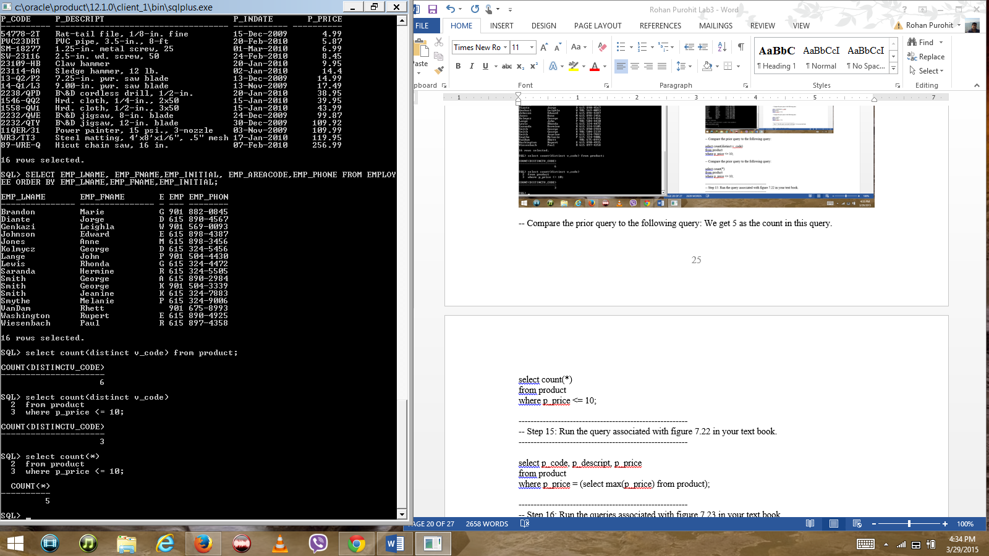

--------------------------------------------------------

-- Step 15: Run the query associated with figure 7.22 in your text book.

--------------------------------------------------------

select p_code, p_descript, p_price

from product

where p_price = (select max(p_price) from product);

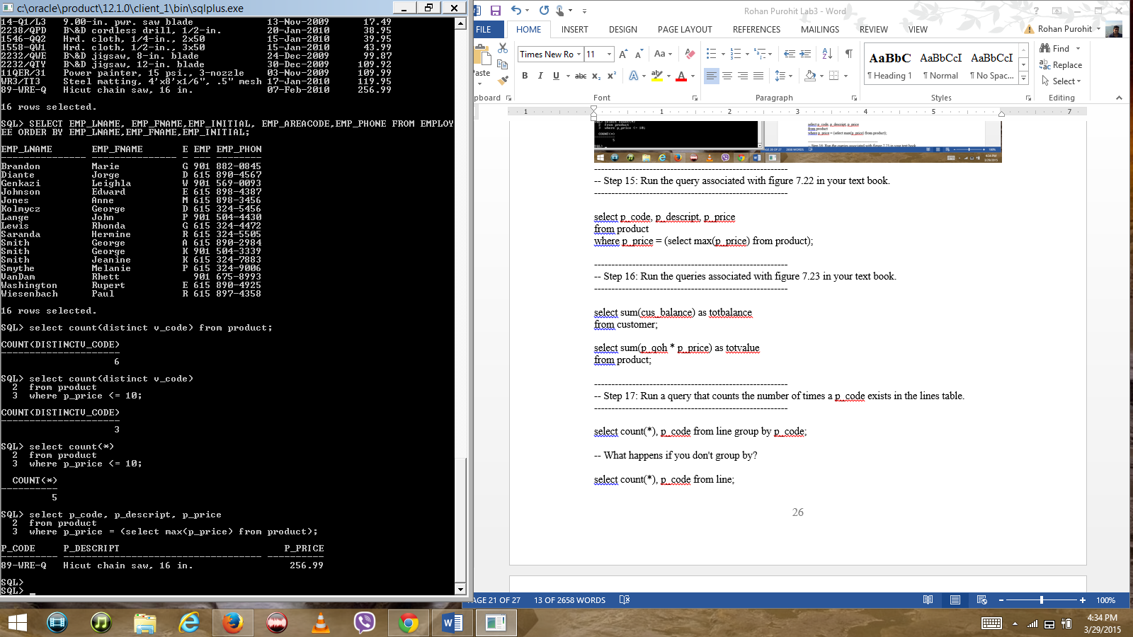

--------------------------------------------------------

-- Step 16: Run the queries associated with figure 7.23 in your text book.

--------------------------------------------------------

select sum(cus_balance) as totbalance

from customer;

select sum(p_qoh * p_price) as totvalue

from product;

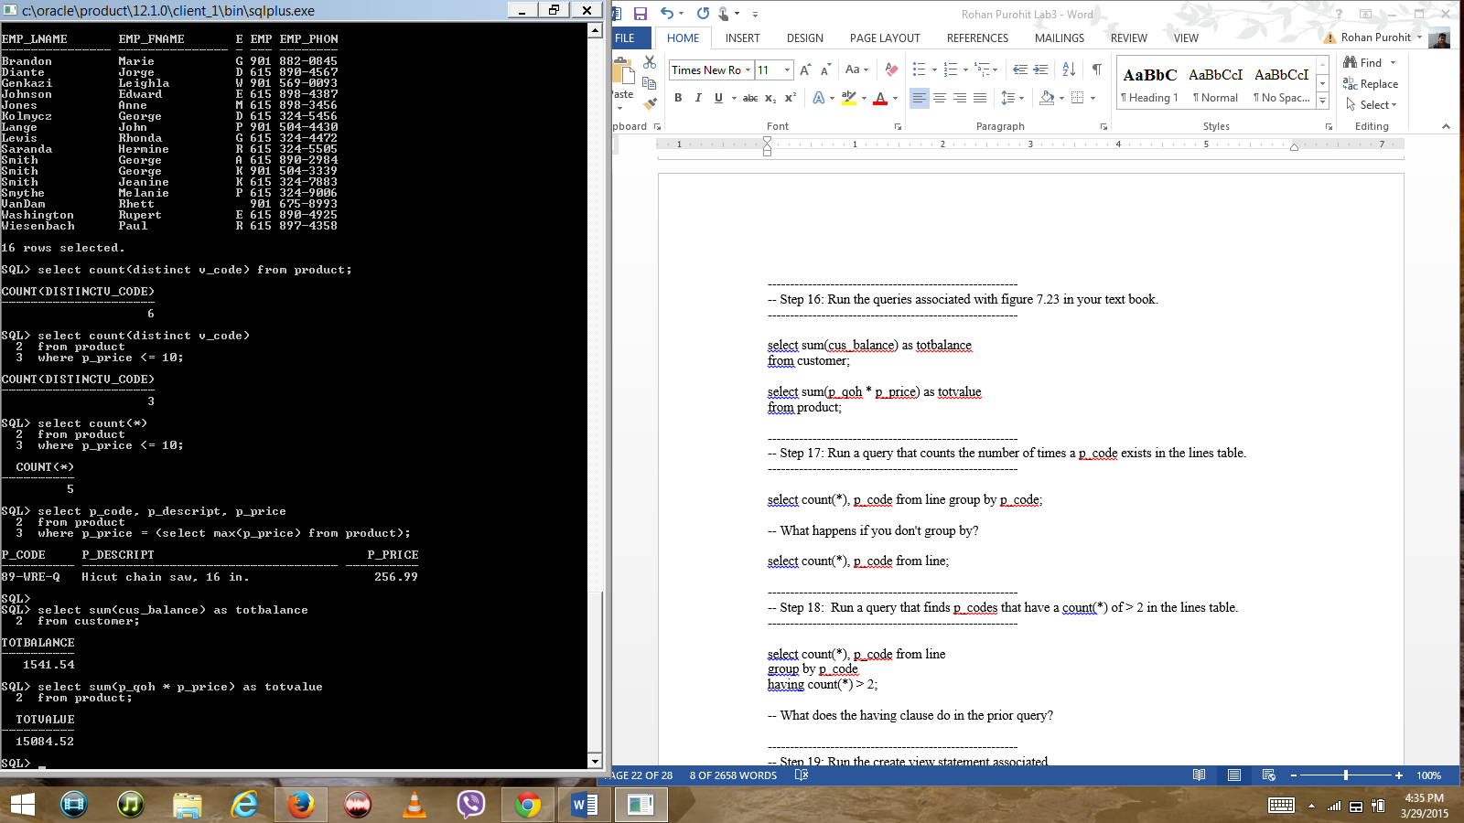

--------------------------------------------------------

-- Step 17: Run a query that counts the number of times a p_code exists in the lines table.

--------------------------------------------------------

select count(*), p_code from line group by p_code;

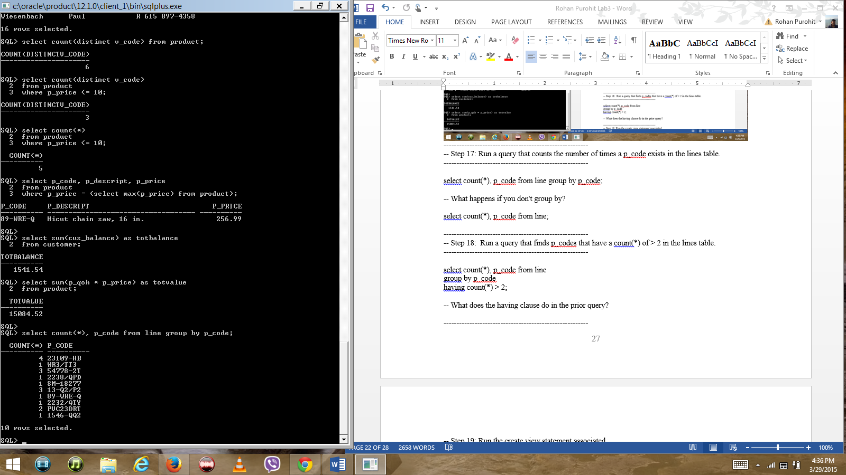

-- What happens if you don't group by? Error – not a single-group group function.

select count(*), p_code from line;

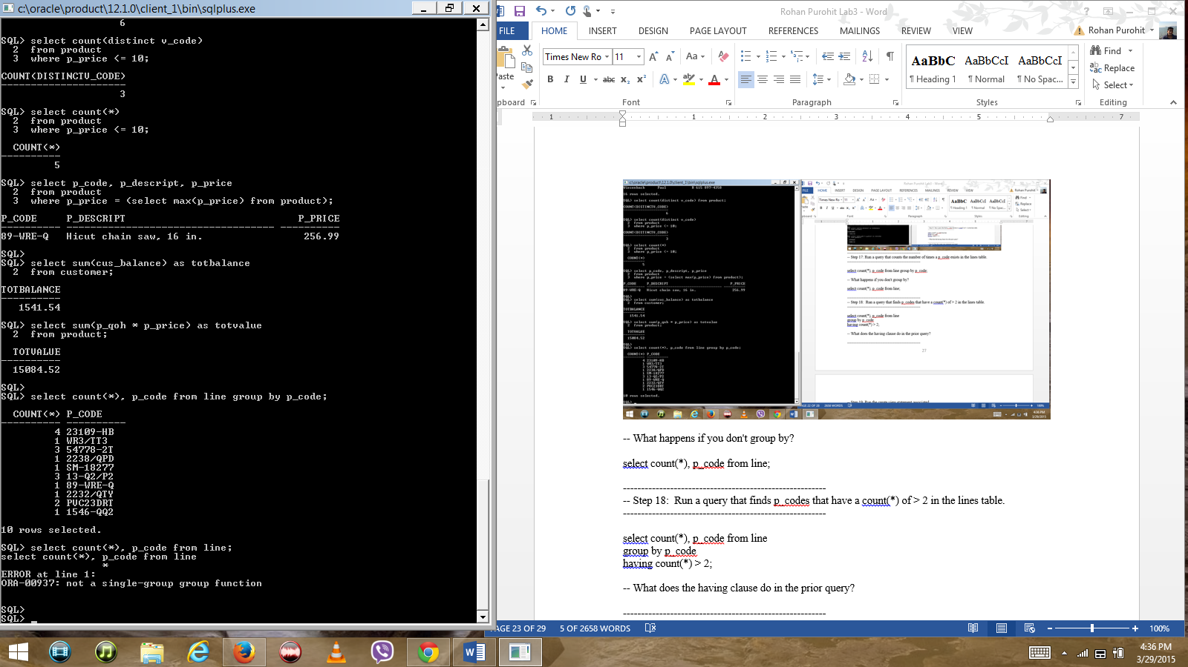

--------------------------------------------------------

-- Step 18: Run a query that finds p_codes that have a count(*) of > 2 in the lines table.

--------------------------------------------------------

select count(*), p_code from line

group by p_code

having count(*) > 2;

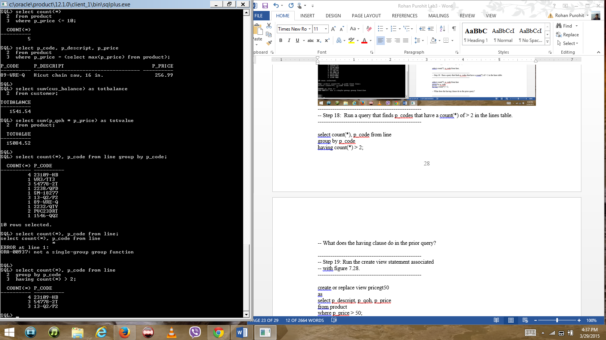

-- What does the having clause do in the prior query? It returns row items with counts greater than 3.

--------------------------------------------------------

-- Step 19: Run the create view statement associated

-- with figure 7.28.

--------------------------------------------------------

create or replace view pricegt50

as

select p_descript, p_qoh, p_price

from product

where p_price > 50;

select * from pricegt50;

insert into product (p_descript, p_qoh, p_price)

values ('SQL Recipes', 5, 75);

select * from pricegt50;

-- Did the view correctly display the new row?

Yes the view displayed the new row.

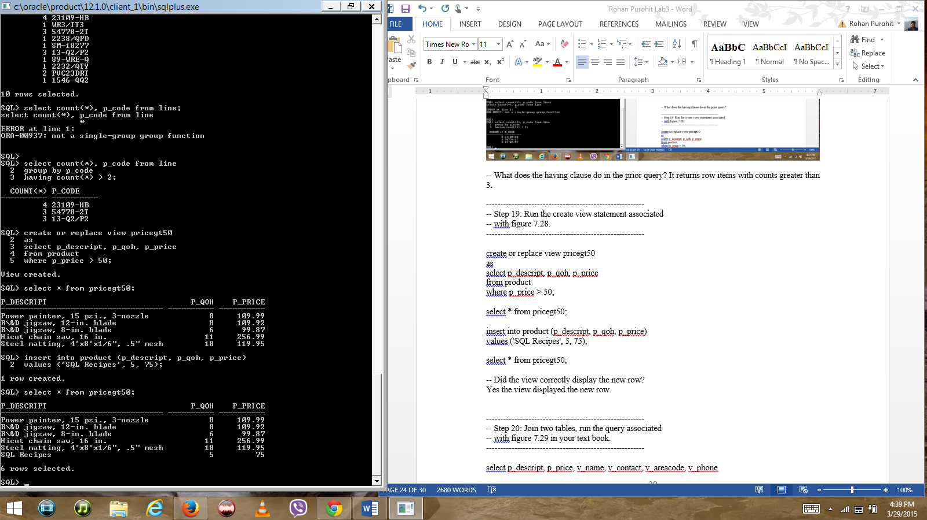

--------------------------------------------------------

-- Step 20: Join two tables, run the query associated

-- with figure 7.29 in your text book.

--------------------------------------------------------

select p_descript, p_price, v_name, v_contact, v_areacode, v_phone

from product, vendor

where product.v_code = vendor.v_code;

-- Compare the prior query to the following query:

-- This one uses the ANSI standard natural join syntax.

select p_descript, p_price, v_name, v_contact, v_areacode, v_phone

from product natural join vendor;

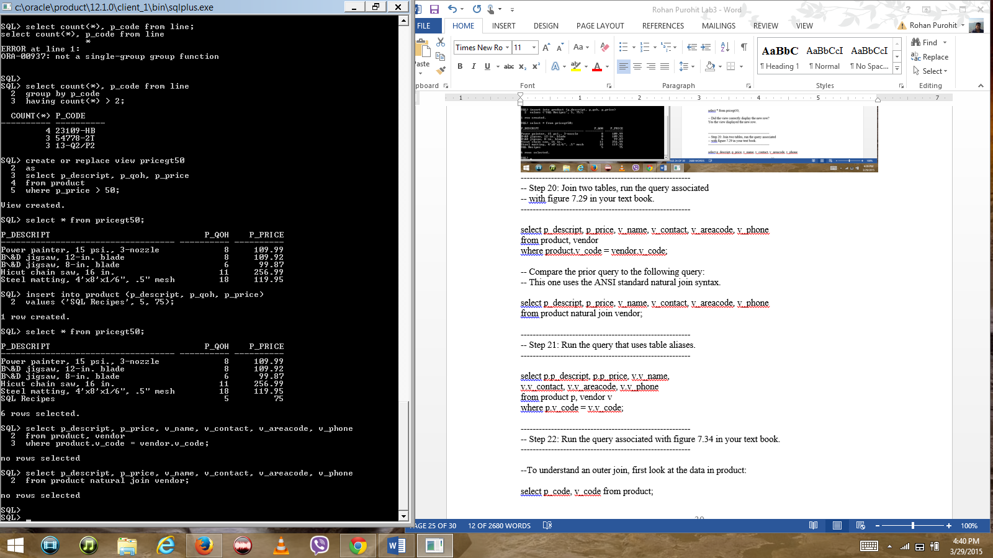

--------------------------------------------------------

-- Step 21: Run the query that uses table aliases.

--------------------------------------------------------

select p.p_descript, p.p_price, v.v_name,

v.v_contact, v.v_areacode, v.v_phone

from product p, vendor v

where p.v_code = v.v_code;

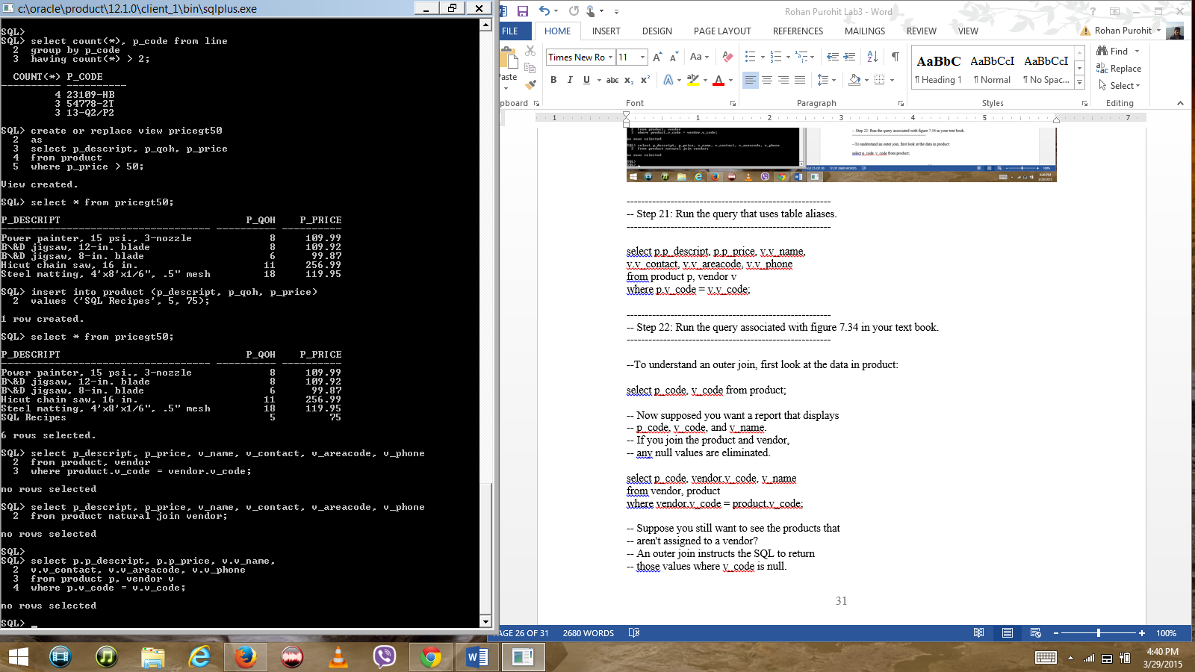

--------------------------------------------------------

-- Step 22: Run the query associated with figure 7.34 in your text book.

--------------------------------------------------------

--To understand an outer join, first look at the data in product:

select p_code, v_code from product;

-- Now supposed you want a report that displays

-- p_code, v_code, and v_name.

-- If you join the product and vendor,

-- any null values are eliminated.

select p_code, vendor.v_code, v_name

from vendor, product

where vendor.v_code = product.v_code;

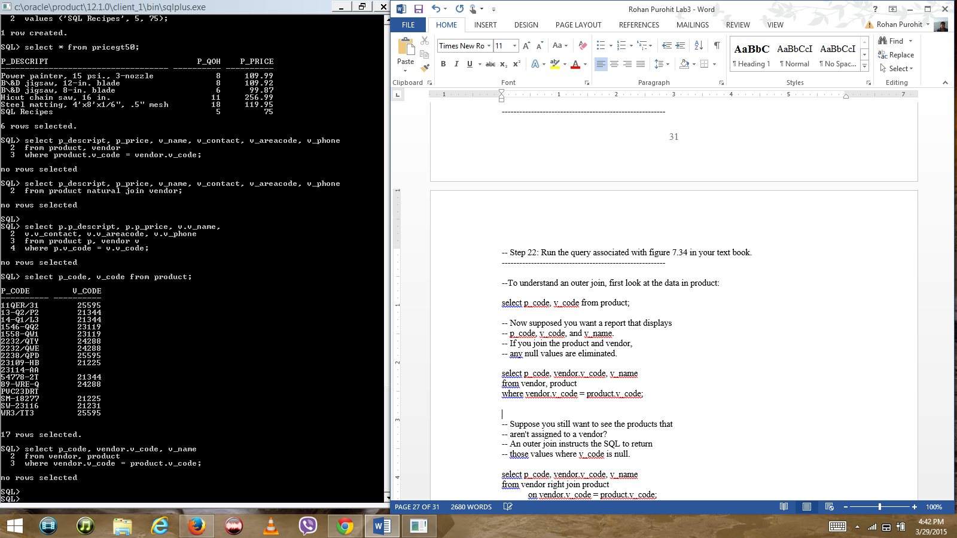

-- Suppose you still want to see the products that

-- aren't assigned to a vendor?

-- An outer join instructs the SQL to return

-- those values where v_code is null.

select p_code, vendor.v_code, v_name

from vendor right join product

on vendor.v_code = product.v_code;

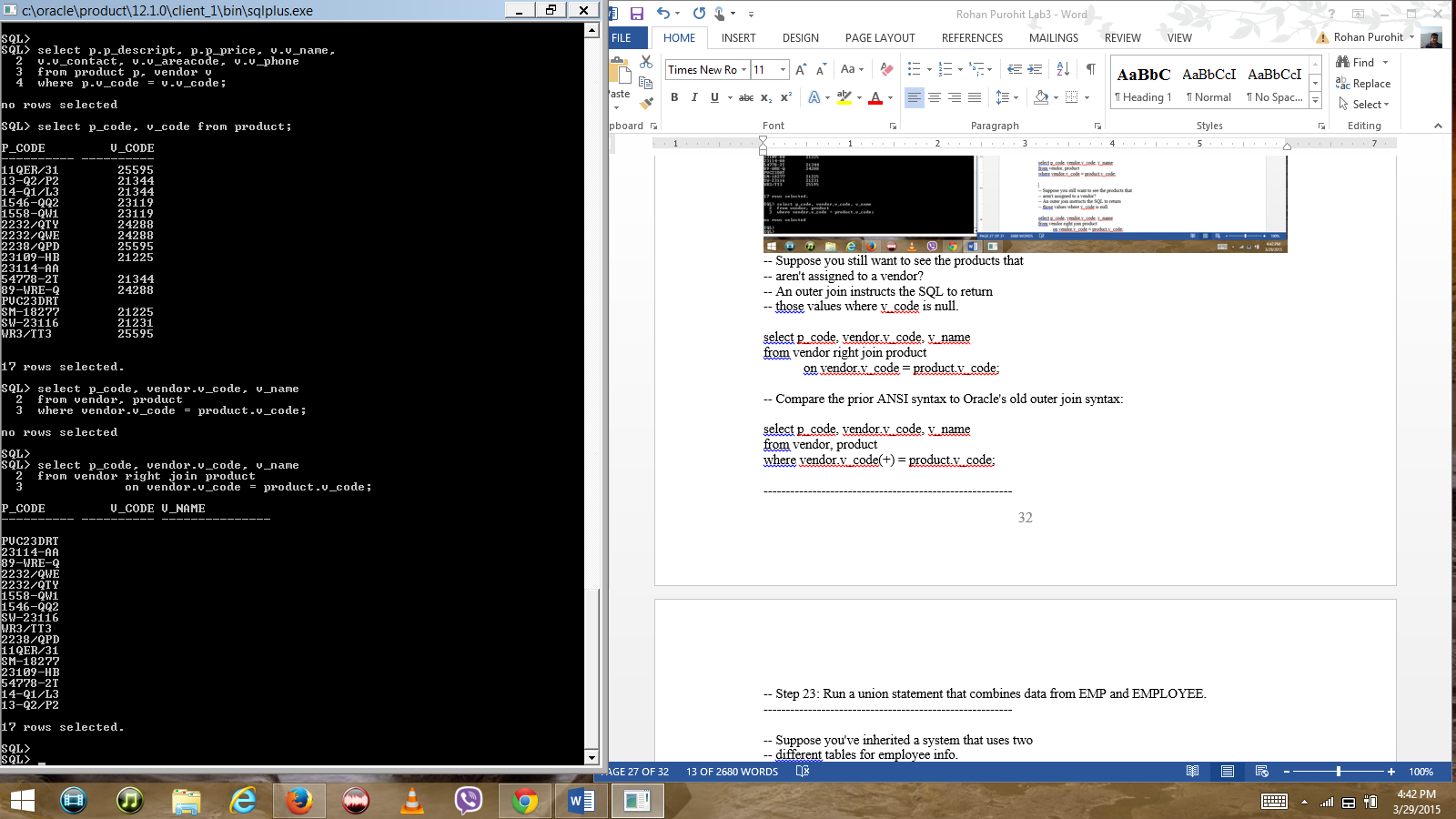

-- Compare the prior ANSI syntax to Oracle's old outer join syntax:

select p_code, vendor.v_code, v_name

from vendor, product

where vendor.v_code(+) = product.v_code;

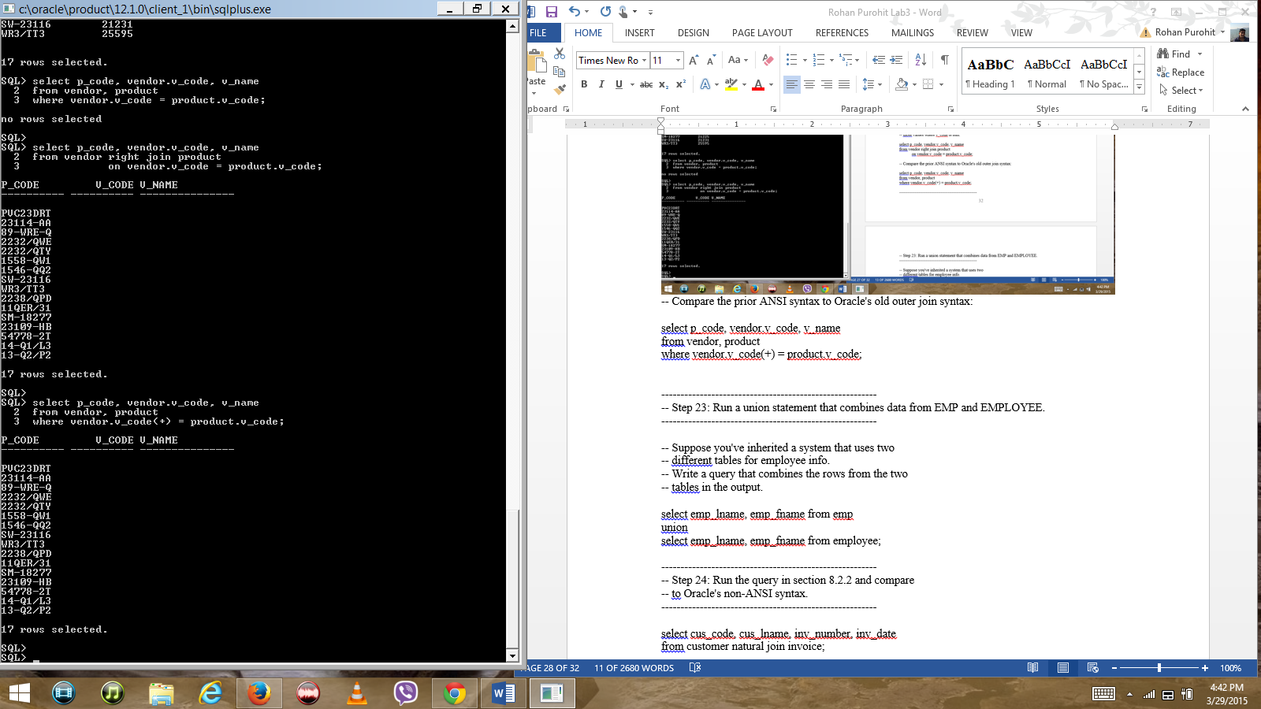

--------------------------------------------------------

-- Step 23: Run a union statement that combines data from EMP and EMPLOYEE.

--------------------------------------------------------

-- Suppose you've inherited a system that uses two

-- different tables for employee info.

-- Write a query that combines the rows from the two

-- tables in the output.

select emp_lname, emp_fname from emp

union

select emp_lname, emp_fname from employee;

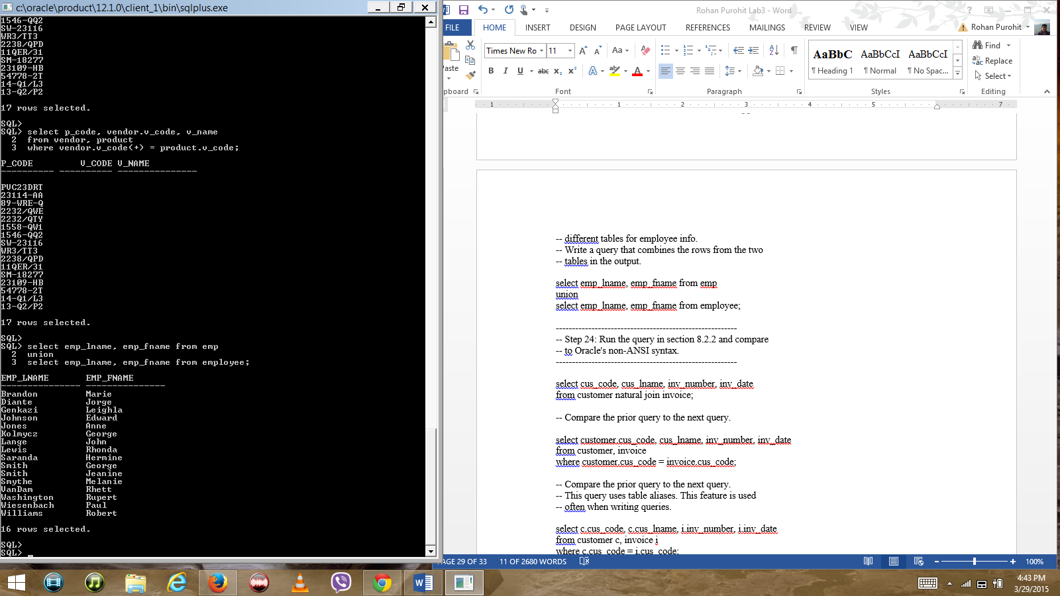

--------------------------------------------------------

-- Step 24: Run the query in section 8.2.2 and compare

-- to Oracle's non-ANSI syntax.

--------------------------------------------------------

select cus_code, cus_lname, inv_number, inv_date

from customer natural join invoice;

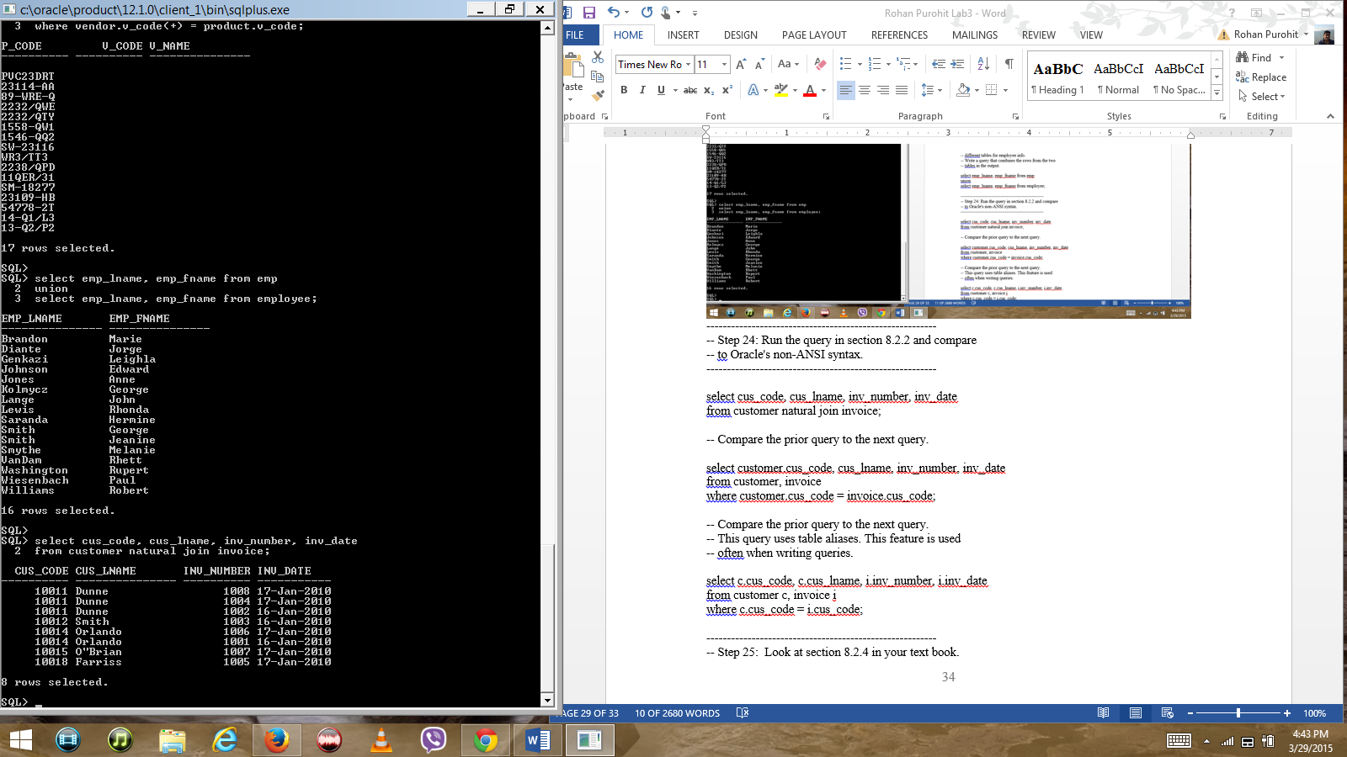

-- Compare the prior query to the next query.- Both queries return the same result set of 8 rows.

select customer.cus_code, cus_lname, inv_number, inv_date

from customer, invoice

where customer.cus_code = invoice.cus_code;

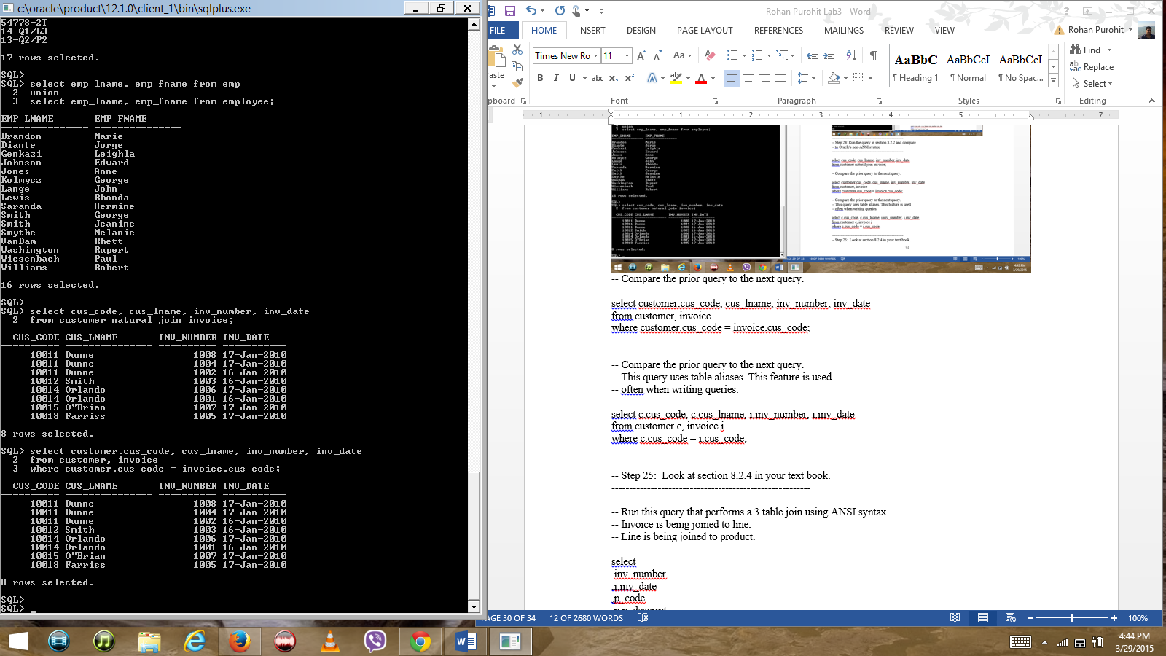

-- Compare the prior query to the next query.

-- This query uses table aliases. This feature is used

-- often when writing queries.

select c.cus_code, c.cus_lname, i.inv_number, i.inv_date

from customer c, invoice i

where c.cus_code = i.cus_code;

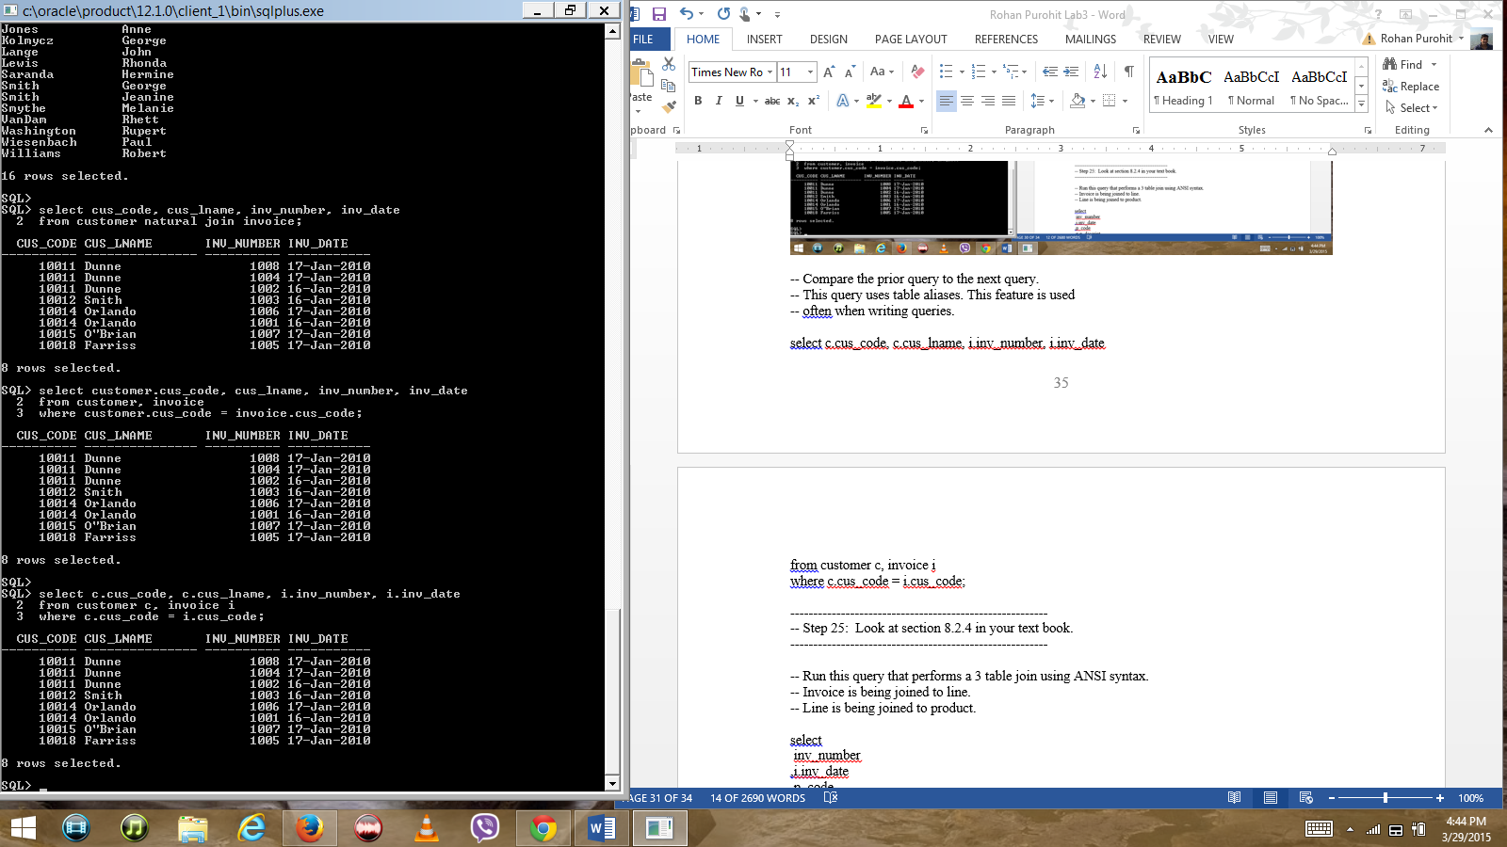

--------------------------------------------------------

-- Step 25: Look at section 8.2.4 in your text book.

--------------------------------------------------------

-- Run this query that performs a 3 table join using ANSI syntax.

-- Invoice is being joined to line.

-- Line is being joined to product.

select

inv_number

,i.inv_date

,p_code

,p.p_descript

,l.line_units

,l.line_price

from invoice i join line l using (inv_number)

join product p using (p_code);

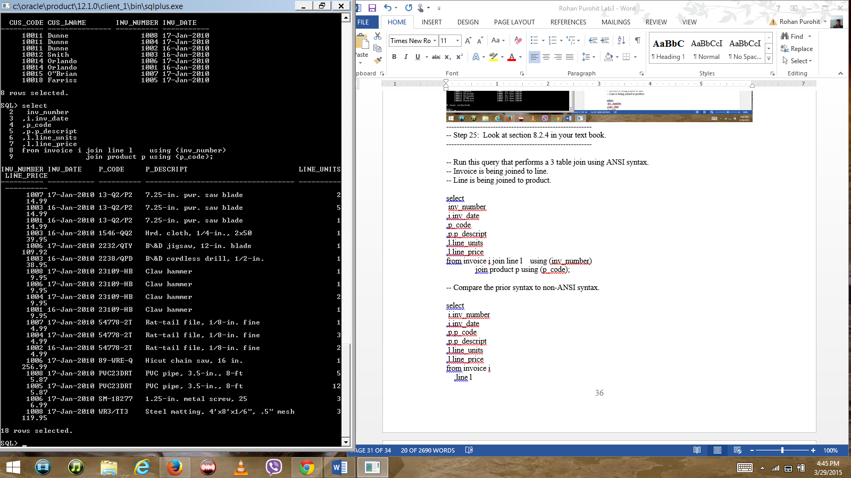

-- Compare the prior syntax to non-ANSI syntax.

select

i.inv_number

,i.inv_date

,p.p_code

,p.p_descript

,l.line_units

,l.line_price

from invoice i

,line l

,product p

where i.inv_number = l.inv_number

and l.p_code = p.p_code;

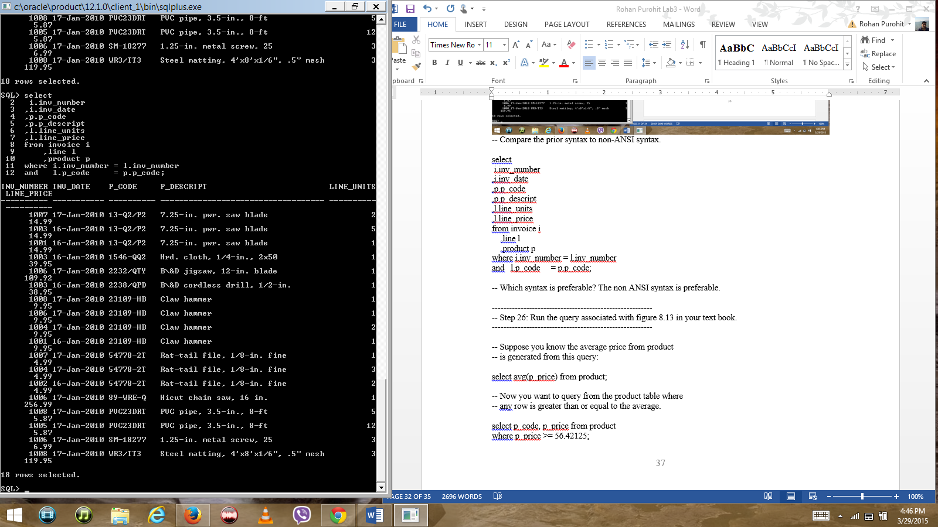

-- Which syntax is preferable? The non ANSI syntax is preferable.

--------------------------------------------------------

-- Step 26: Run the query associated with figure 8.13 in your text book.

--------------------------------------------------------

-- Suppose you know the average price from product

-- is generated from this query:

select avg(p_price) from product;

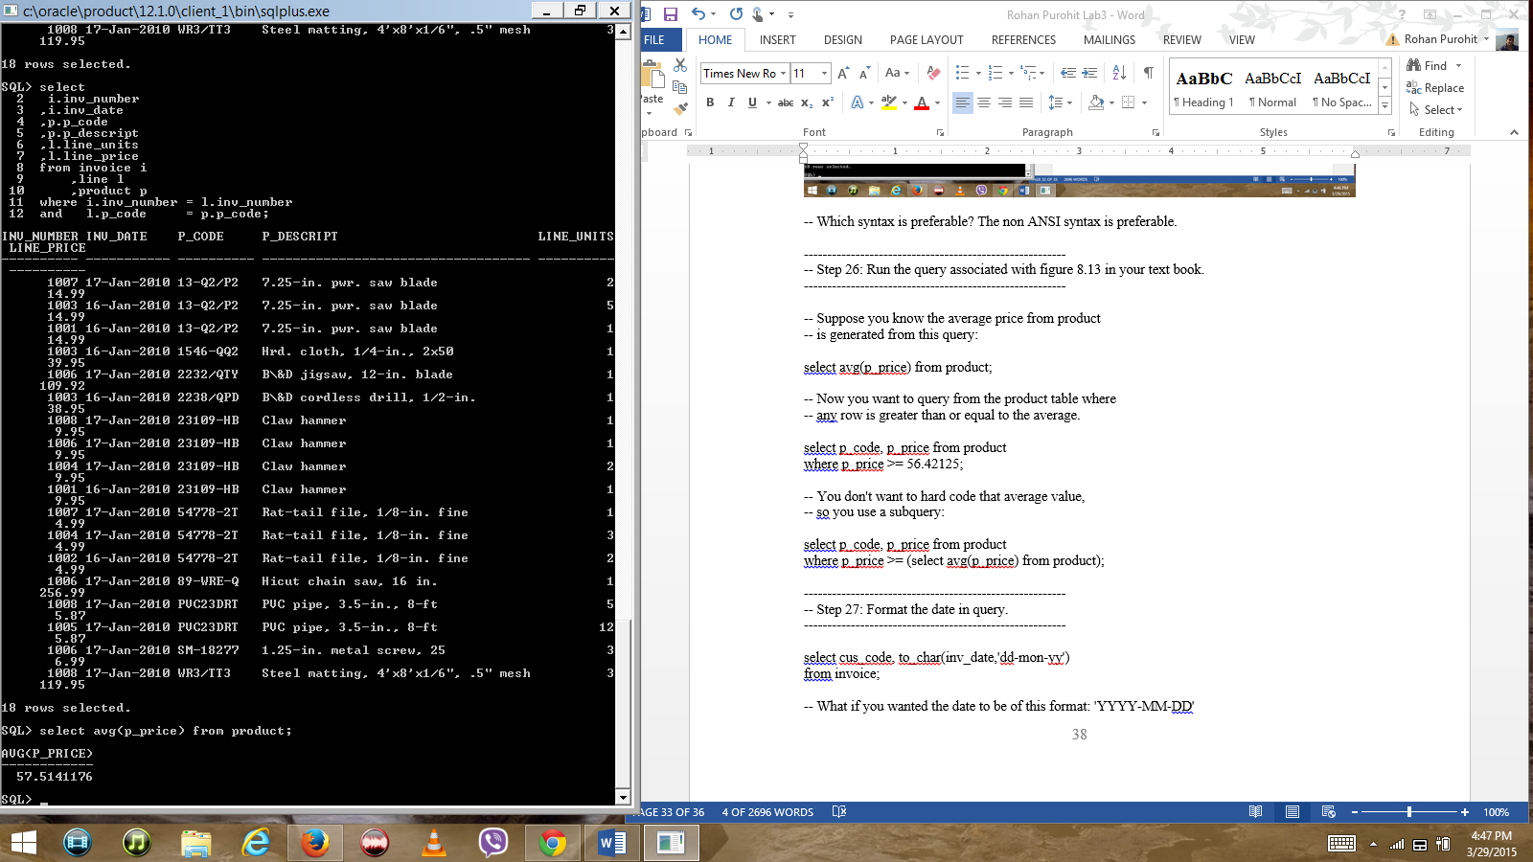

-- Now you want to query from the product table where

-- any row is greater than or equal to the average.

select p_code, p_price from product

where p_price >= 56.42125;

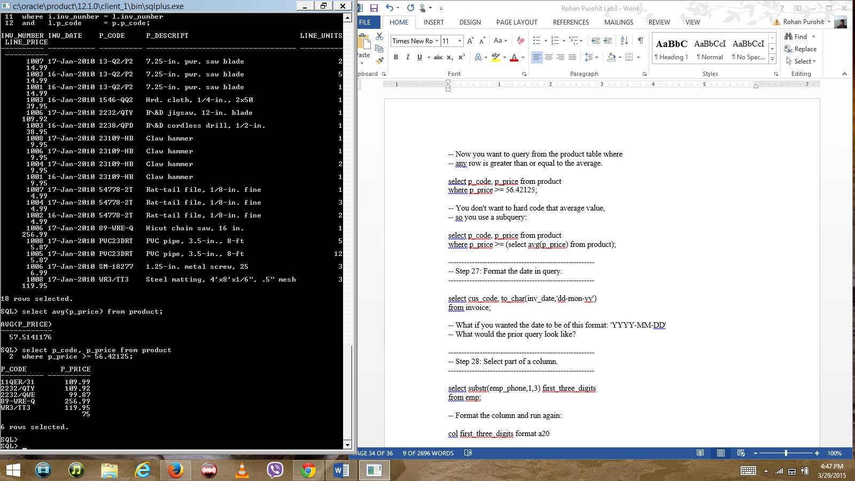

-- You don't want to hard code that average value,

-- so you use a subquery:

select p_code, p_price from product

where p_price >= (select avg(p_price) from product);

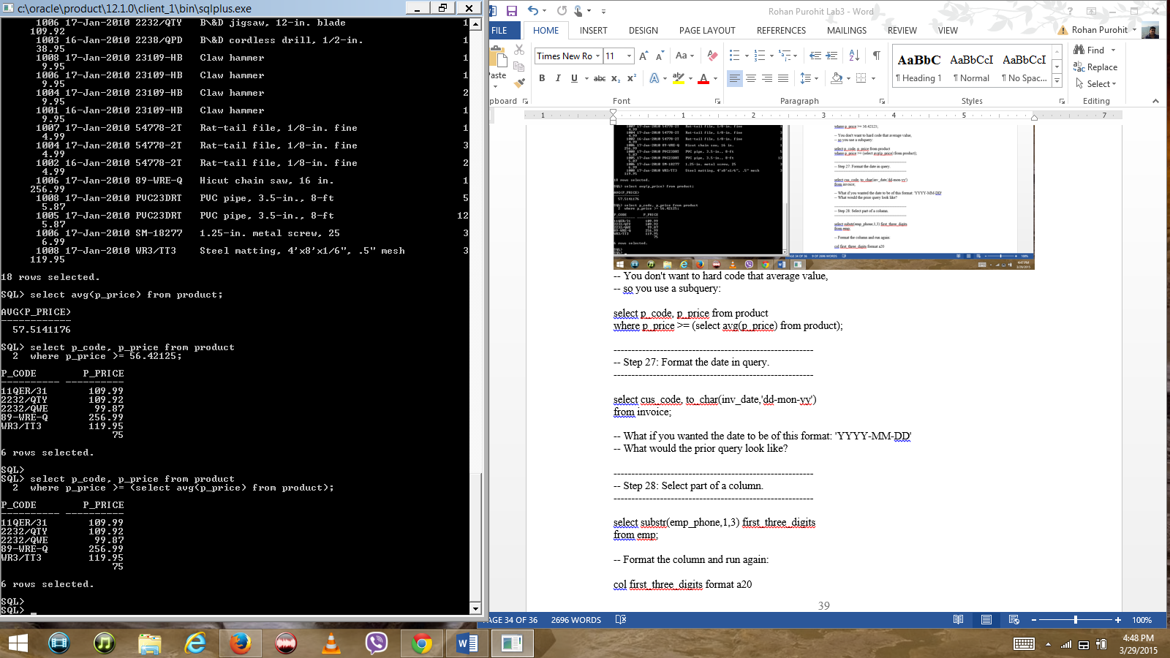

--------------------------------------------------------

-- Step 27: Format the date in query.

--------------------------------------------------------

select cus_code, to_char(inv_date,'dd-mon-yy')

from invoice;

-- What if you wanted the date to be of this format: 'YYYY-MM-DD'

-- What would the prior query look like?

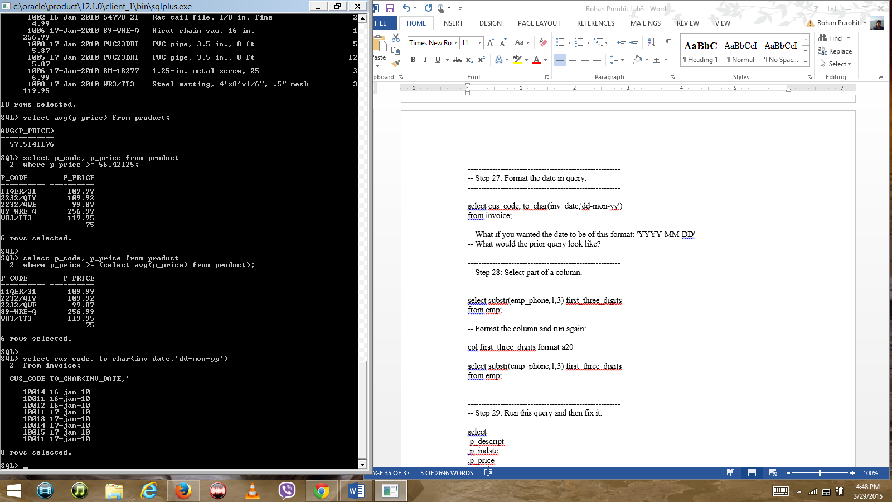

--------------------------------------------------------

-- Step 28: Select part of a column.

--------------------------------------------------------

select substr(emp_phone,1,3) first_three_digits

from emp;

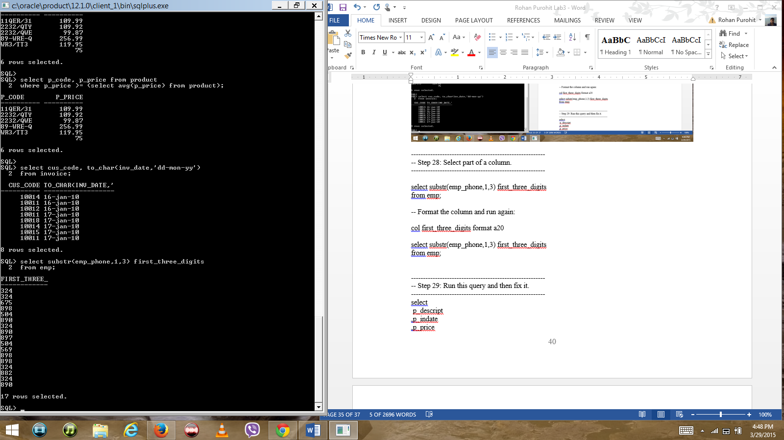

-- Format the column and run again:

col first_three_digits format a20

select substr(emp_phone,1,3) first_three_digits

from emp;

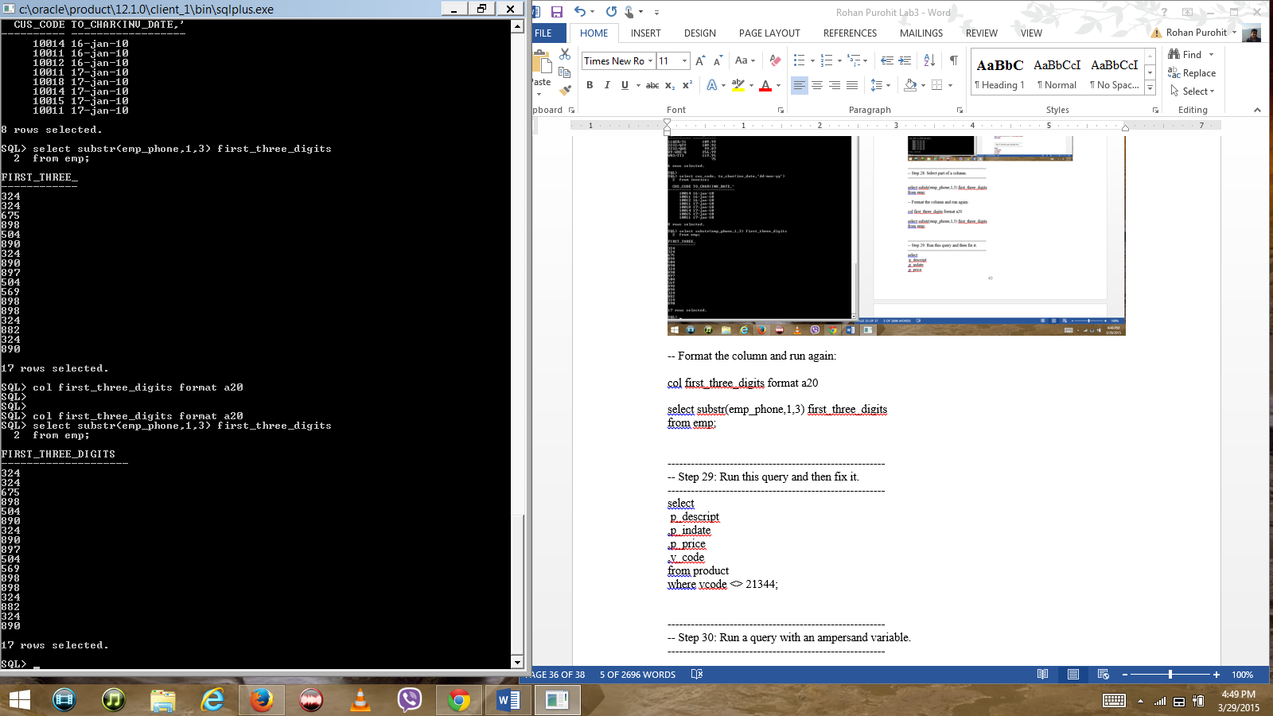

--------------------------------------------------------

-- Step 29: Run this query and then fix it.

--------------------------------------------------------

select

p_descript

,p_indate

,p_price

,v_code

from product

where vcode <> 21344; // where v_code <> 21344;

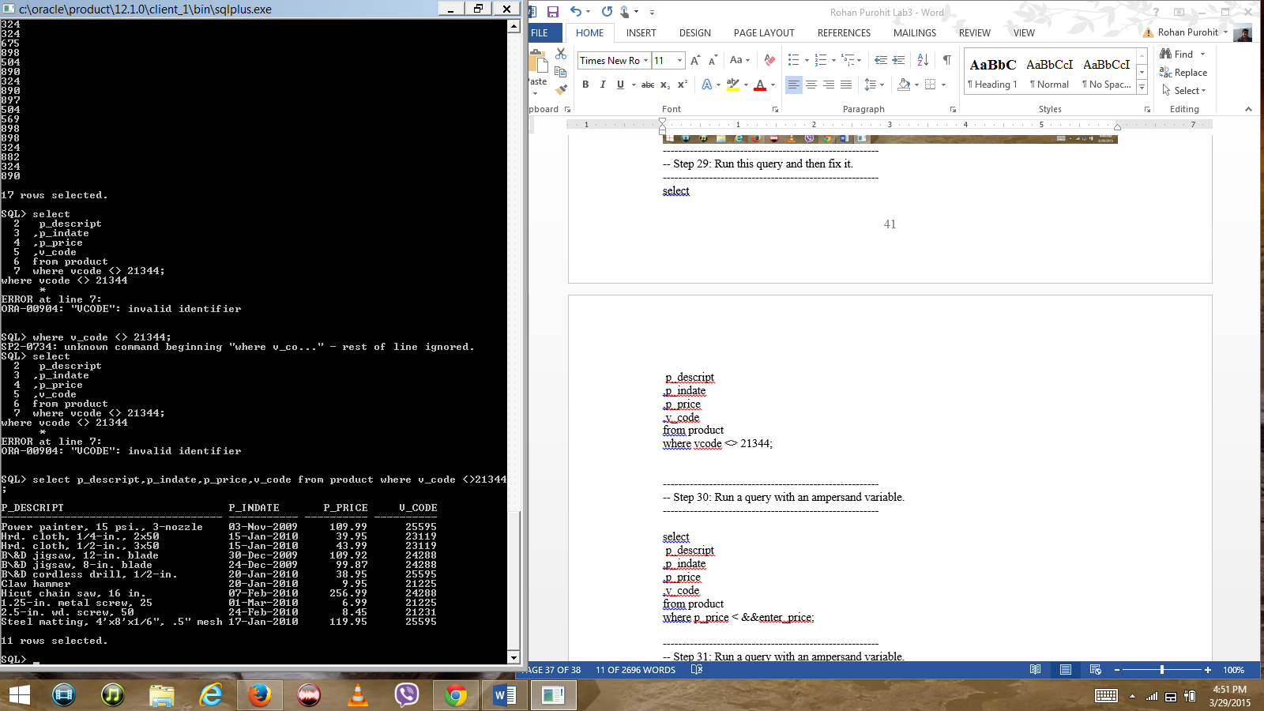

--------------------------------------------------------

-- Step 30: Run a query with an ampersand variable.

--------------------------------------------------------

select

p_descript

,p_indate

,p_price

,v_code

from product

where p_price < &&enter_price;

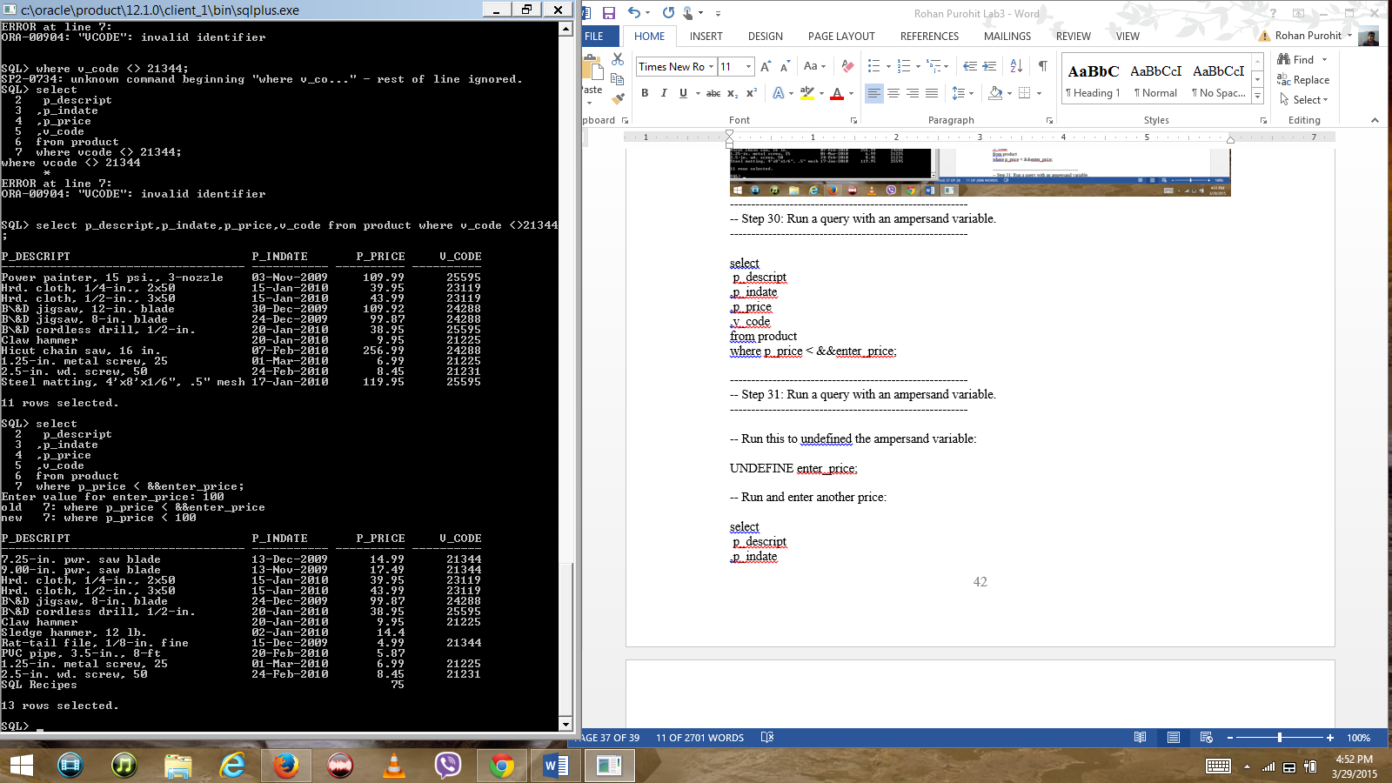

--------------------------------------------------------

-- Step 31: Run a query with an ampersand variable.

--------------------------------------------------------

-- Run this to undefined the ampersand variable:

UNDEFINE enter_price;

-- Run and enter another price:

select

p_descript

,p_indate

,p_price

,v_code

from product

where p_price < &&enter_price;

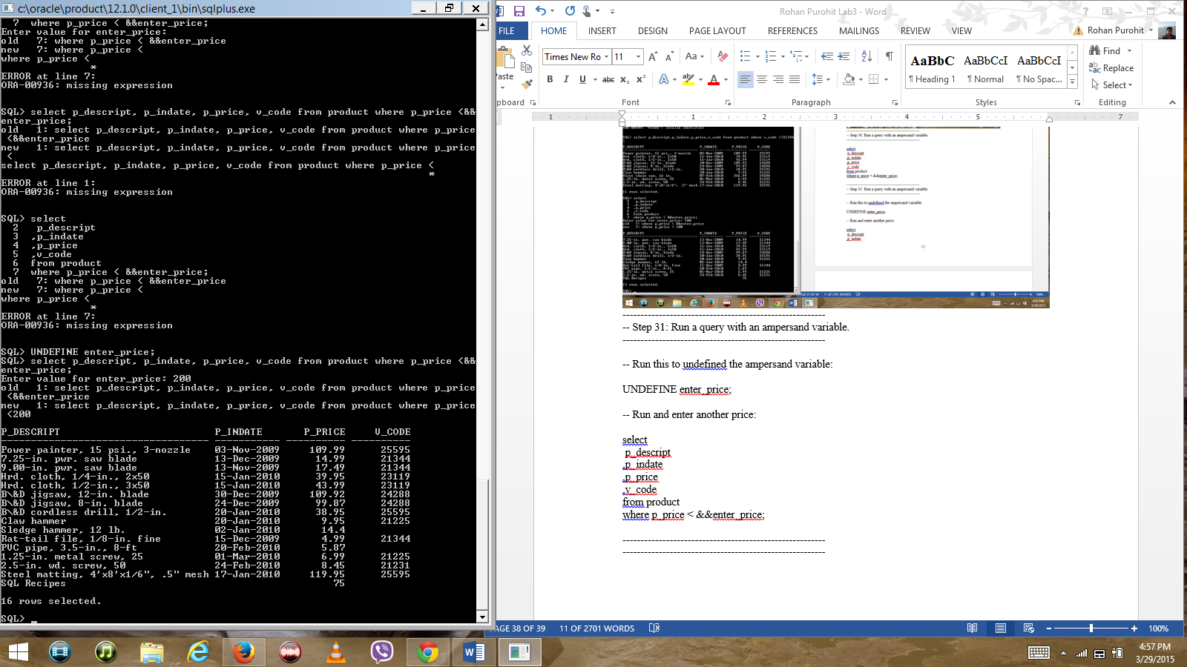

--------------------------------------------------------

--------------------------------------------------------

**MSCD 600 Database Architecture**

**Labs Rubric**

|  |  |
| --- | --- |
| **Grade** | **Rubric: Labs** |
| A  90-100% | -The lab work is technically sound  -The lab work addresses the criteria and exceeds the minimum requirements for the lab assignment.  -Met submission deadline.  - The deliverable format meets all requirements.  -Each item is clearly delineated and easy to follow.  -The submitted work is free from errors. |
| B  80-89% | -The lab work is technically sound  -The lab work addresses the criteria and meets the minimum requirements for the lab assignment.  -Met submission deadline.  - The deliverable format meets all requirements.  -Most items are clearly delineated and easy to follow.  -The submitted work has one to two errors. |
| C  70-79% | -The lab work is technically sound  -The lab work addresses the criteria and meets the minimum requirements for the lab assignment.  -Met submission deadline.  - The deliverable format meets most requirements.  -Most items are clearly delineated and easy to follow.  -The submitted work has more than two errors. |
| D  60-69% | -The lab work is not technically sound  -The lab work addresses the criteria and meets some of the minimum requirements for the lab assignment.  -Met submission deadline.  - The deliverable format meets some requirements.  -Few items are clearly delineated and easy to follow.  -The submitted work has more than three errors. |
| F  Less than 60% | -The lab work is not technically sound  -The lab work does not meet the base criteria nor the minimum requirements for the lab assignment.  -Did not meet submission deadline.  -The deliverable format meets some requirements.  -Few items are clearly delineated and easy to follow.  -The submitted work has more than four errors. |